**AMERICAN INTERNATIONAL UNIVERSITY BANGLADESH (AIUB)**

**FACULTY OF SCIENCE & TECHNOLOGY**



Course Title

**INTRODUCTION TO DATABASE**

**Summer 2022-2023**

**Section: E, Group: 08**

**REPORT ON**

**Online Shopping System**

**Supervised By**

**MD Sajid Bin Faisal**

**Submitted By:**

|  |  |
| --- | --- |
| **Name** | **ID** |
| **IMTIAZ, FAHMID** | **21-45689-3** |
| **SHAMIK BISWAS** | **22-48893-3** |
| **AHAMED, SHEIKH ARFIN** | **22-48898-3** |
| **MOHAMMED RUHIT** | **22-48927-3** |

|  |  |  |
| --- | --- | --- |
| **TOPICS** | | **Page no.** |
| 1. **Title Page** | | **1** |
| 1. **Table of Content** | | **2** |
|  | 1. **Introduction** | **3** |
|  | **Case Study** | **4** |
|  | **ER diagram** | **5** |
|  | **Normalization** | **6-11** |
|  | **Finalization** | **12** |
|  | **Table Creation** | **13-19** |
|  | 1. **Value Insertion** | **20-32** |
|  | 1. **Query Test** 2. **View Creation** 3. **Database Connection** 4. **Conclusion** | **33-38**  **39-40**  **41**  **42** |
|  |  |  |
|  |  |  |
|  |  |  |
|  |  |  |
|  |  |  |

**TABLE OF CONTENTS**

**1. Introduction:**

**Software:** Oracle Database 10g Express Edition.

**Purpose:** The online shopping system project was to create a robust and user-friendly platform that

allows customers to shop for products online. The project aimed to provide a convenient and efficient way

for customers to explore, select, and purchase products from various stores, all within a digital environment. By designing a comprehensive database schema and implementing relevant queries and views, the project aimed to enable smooth customer interactions, streamline order processing, track payments, and offer valuable insights into customer behavior and store performance. Ultimately, the project's purpose was to enhance the shopping experience, promote online commerce, and showcase the importance of well-structured databases in modern business operations.

**Advantage:** The online shopping system offers several advantages that transform the shopping experience. It provides unmatched convenience, enabling customers to shop from anywhere at any time. The diverse product range allows users to explore a wide array of offerings, while time savings are realized by eliminating the need to travel and wait in queues. With continuous availability, customers can shop around the clock, and efficient order processing ensures smooth transactions. Real-time order tracking enhances transparency, and personalized recommendations cater to individual preferences. Flexible payment options accommodate various needs, and data insights drive smarter business decisions. The system's global reach extends market boundaries, and its environmentally conscious approach aligns with sustainable practices. These combined advantages redefine shopping by focusing on ease, accessibility, efficiency, and customer satisfaction.

**2.Case study:**

Online Shopping System

In an online shopping system, a customer can place multiple orders. A

customer is identified by c-id, c-name, c-address, phone-num. The order has

o-id, o-date. It also has an order detail which contains order details id, p-

name, t-price, quantity, discount. The customer will order from the store. One

can order from multiple stores and place multiple order from one store. The

store has a store name, store id, and store address, The product is delivered.

from the store. The product holds product id, brand id, category id, and price.

Multiple products can be delivered from a store. Customers can make there.

payment easily. The payment has payment id, amount, and payment methods.

Which has credit card, cash, bank transfer. One customer can only make one

payment. Can check and investigate order and store. The administrator is

identified by id, name, salary and phone number.

**3.ER DIAGRAMG:**



**4.Normalization:**



**CAN:**

**UNF:**

C-id, c-address, c-name, Phone-num, O-id, o-date

**1NF:**

C-id, c-address, c-name, Phone-num, O-id, o-date

**2NF:**

(i) C-id, c-name, Phone-num, c-address.

(ii) O-id (PK), o-date, c-id (FK).

## **3NF:**

## will be some as 2nf.



**HAS:**

**UNF:**

Od-id, o-date, O-id, P-name, t-price, Quantity, Discount

**1NF:**

Od-id, o-date, O-id, P-name, t-price, quantity, discount

**2NF:**

(i) O-id, o-date,

(ii) od-id, P-name, t-price, Quantity, Discount.

## (iii)od-id (PK), O-id (FK).

## **3NF:**

## will be some as 2nf.



**PAYS:**

**UNF:**

c-name, Phone-num, C-ID, c-address, Pay-ID, Amount,

**1NF:**

c-name, Phone-num, C-ID, c-address, Pay-ID, Amount,

**2NF:**

(i) C-id, c-name, Phone-num, c-address.

(ii) Pay-ID, Amount, (Payment)

(iii) C-Name (PK), Pay-ID(FK).

**3NF:**

Will be some as 2nf.



**FROM:**

**UNF:**

O-ID, o-date, S-ID, S-Name, S-address

**1NF:**

O-ID, o-date, S-ID, S-Name, S-address

**2NF:**

(i) O-id, Date (date)

(ii)S-id, S-name, S-address.

(iii)O-id (PK), S-id(FK).

**3NF:**

will be same as 2nf



**Delivers:**

**UNF:**

S-id, S-name, S-address, p-id, B-id, Ca-id, p-price

**1NF:**

S-id, S-name, S-address, p-id, B-id, Ca-id, p-price

**2NF:**

(i) S-id, S-name, S-address.

(ii) p-id, B-id, Ca-id, p-price.

(iii)S-id (PK), P-id (FK).

**3NF:**

will be same as 2NF.



**Observers:**

**UNF:**

O-id, date, S-id, S-name, S-address, A-id, A-id, A-name.

**1NF:**

O-id, date, S-id, S-name, S-address, A-id, A-id, A-name.

**2NF:**

(i) A-id (PK), A-name, O-id (FK).

(ii) O-id, o-date, S-id, S-name, S-address.

**3NF:** Will be same as 2NF.

**Finalization:**

(1) C-id, c-name, Phone-num, c-address (Customer)

(2) O-id (PK), o-date, c-id (FK) (Order)

(3)O-id, Date (date)

(4) od-id, P-name, t-price, Quantity, Discount (details)

(5) od-id (PK), O-id (FK) (has)

~~(6)C-id, c-name, Phone-num, c-address~~ ~~(customer)~~

(7) Pay-ID, Amount (payment)

(8) C-Name (PK), Pay-ID(FK) (pays)

~~(9)O-id, Date (date)~~

(10) S-id, S-name, S-address (store)

(11) O-id (PK), S-id (FK) (from)

~~(12)S-id, S-name, S-address (store)~~

(13) p-id, B-id, Ca-id, p-price (product)

(14) S-id (PK), P-id (FK)(Delivers)

(15) A-id (PK), A-name, O-id (FK) (administration)

(16) O-id, o-date, S-id, S-name, S-address (observers)

**6.Table Creation**

**Figure-6.1**

**Customer table creation:**

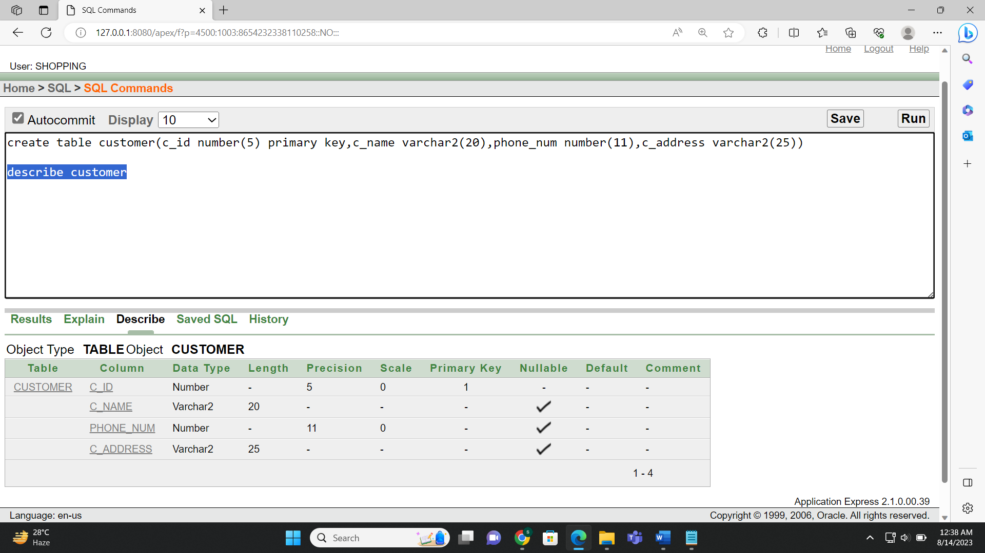



**Figure-6.2**

**Orders table creation:**

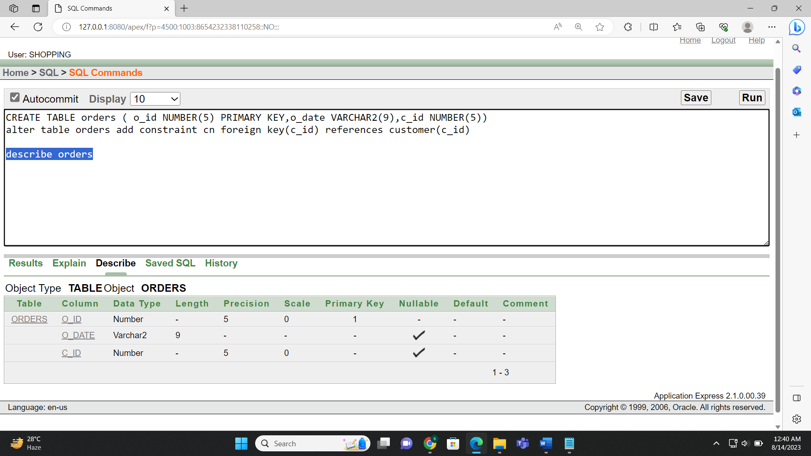

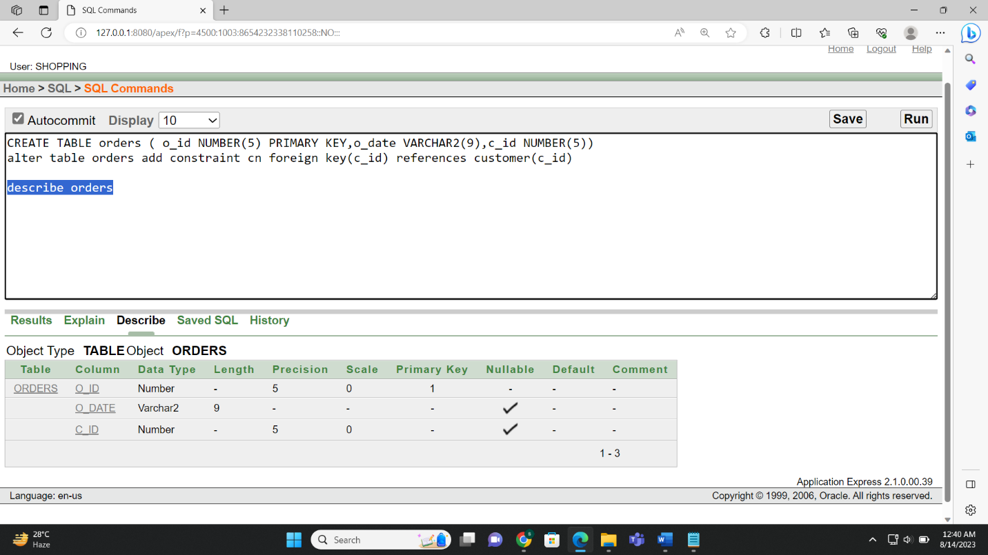

**Figure-6.3**

**Dates table creation:**

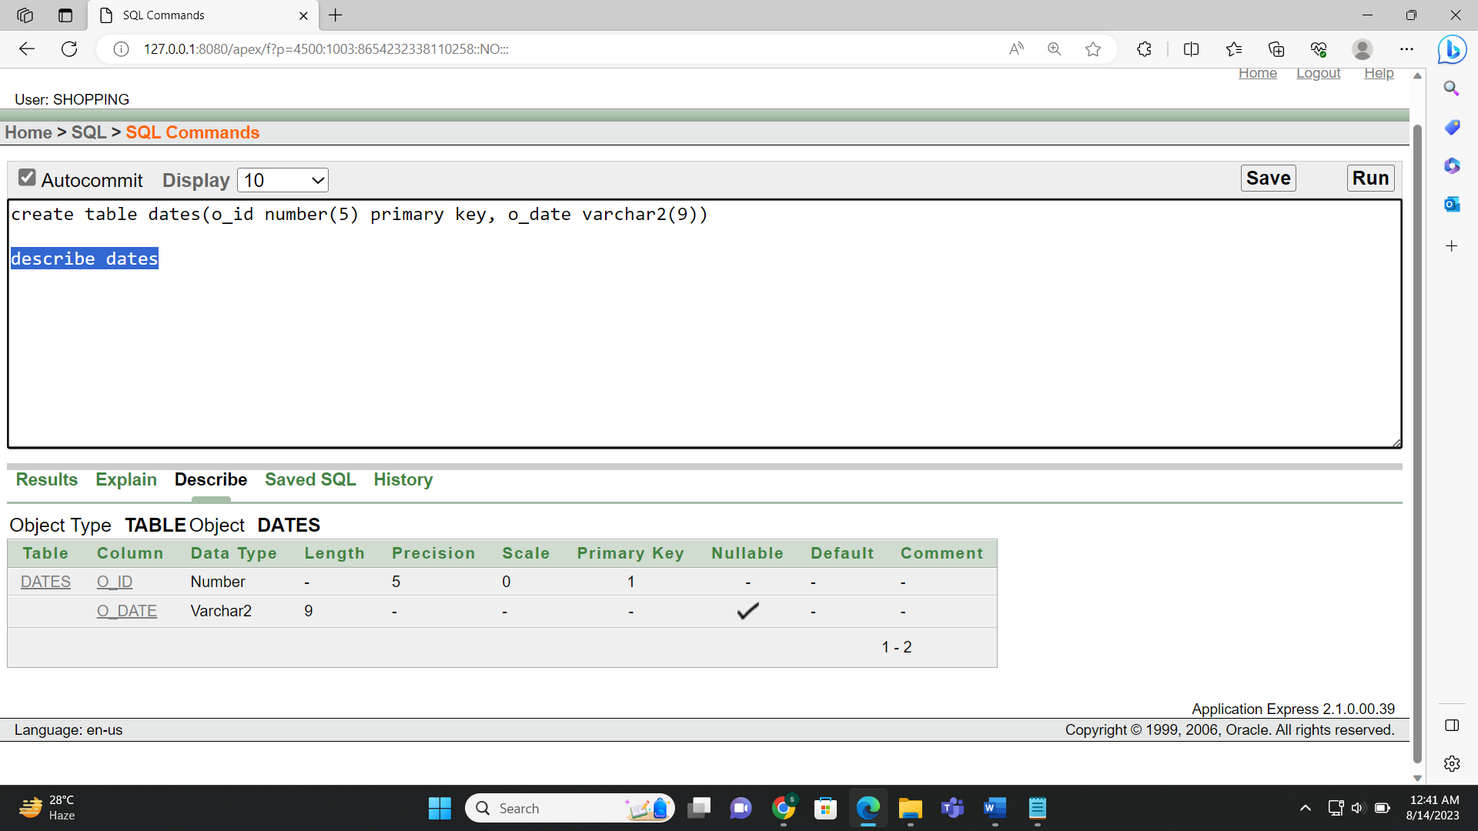



**Figure-6.4**

**Details table creation:**

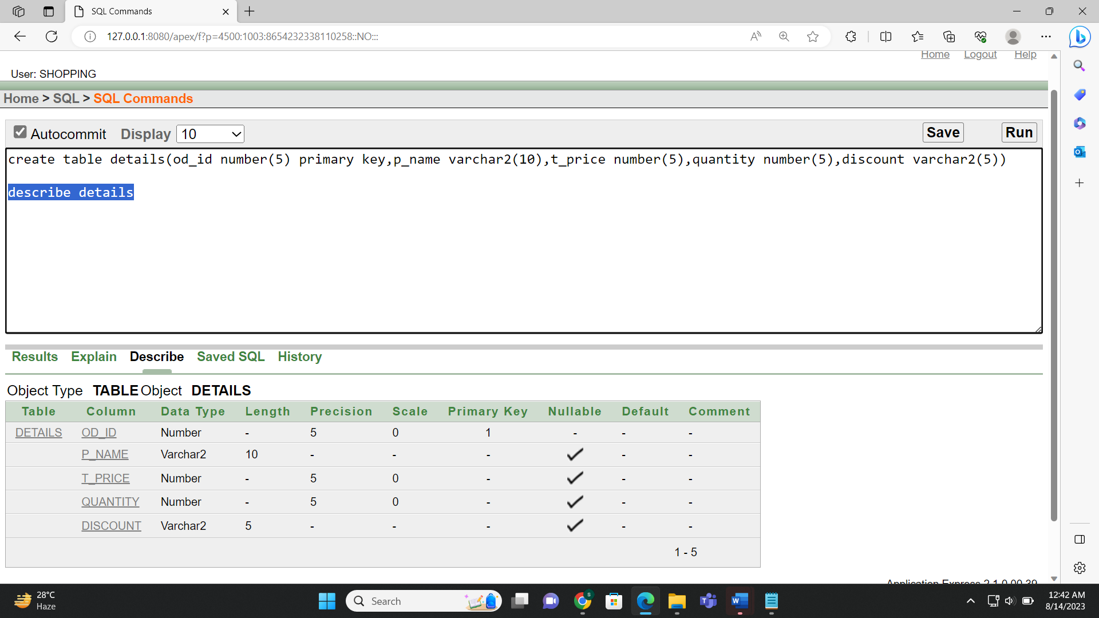



**Figure-6.5**

**Has table creation:**

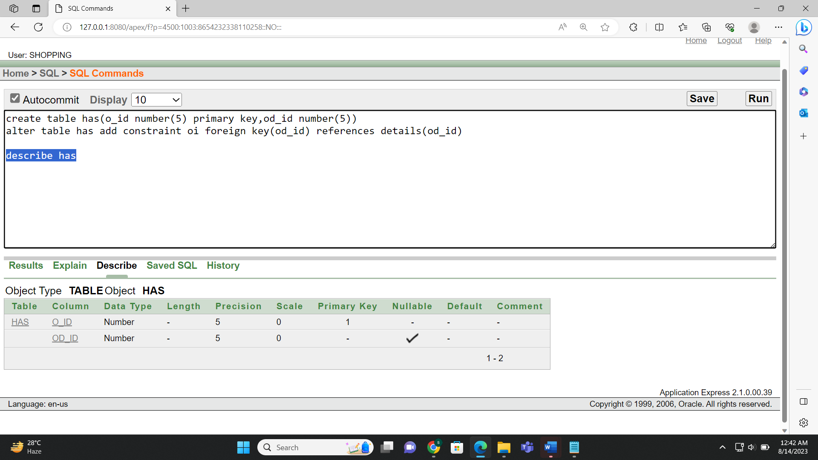



**Figure-6.6**

**Payment table creation:**

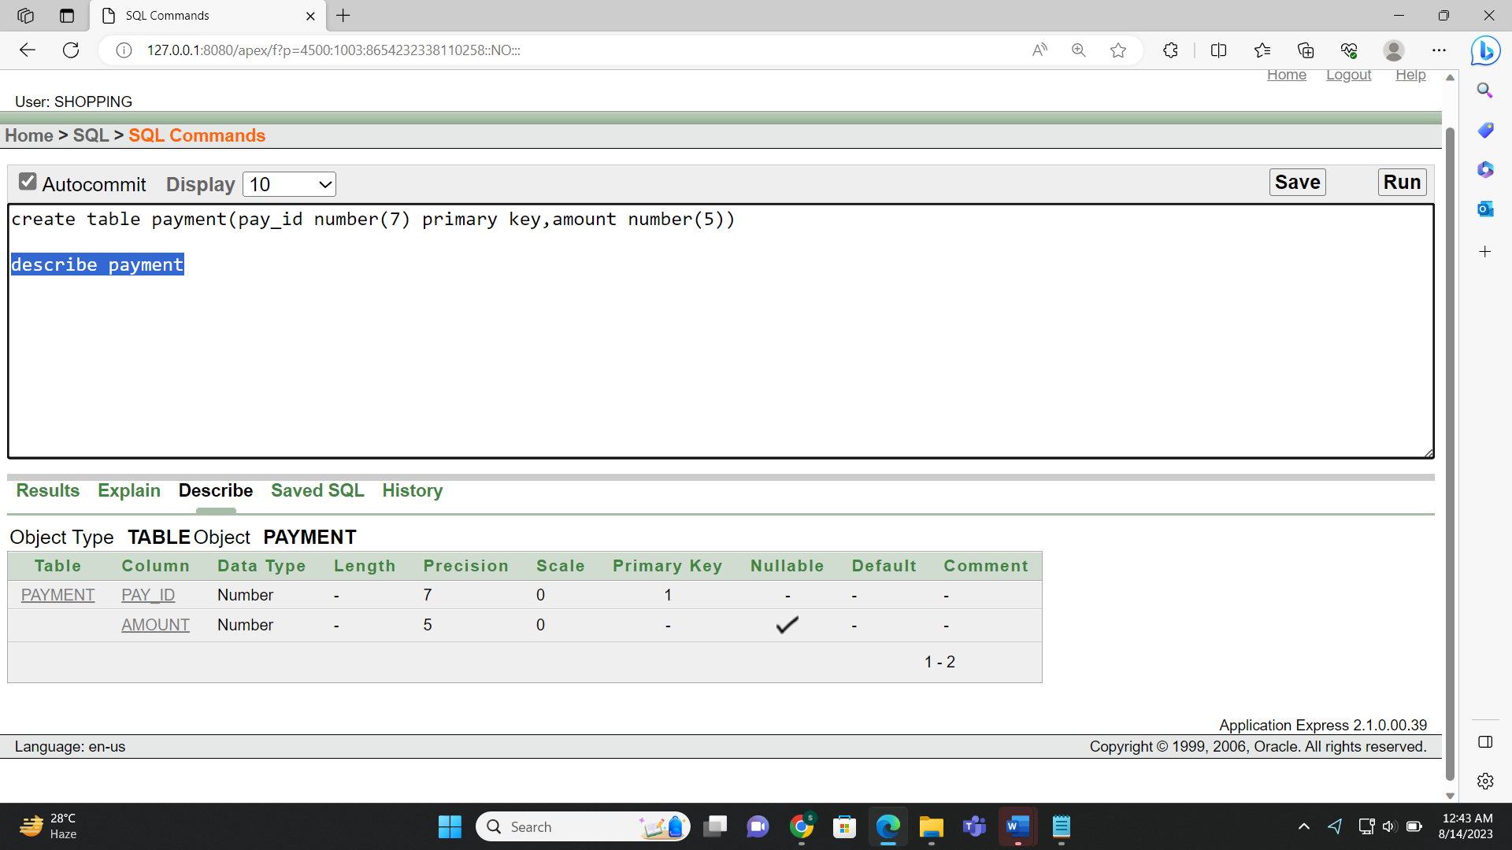



**Figure-6.7**

**Pays table creation:**

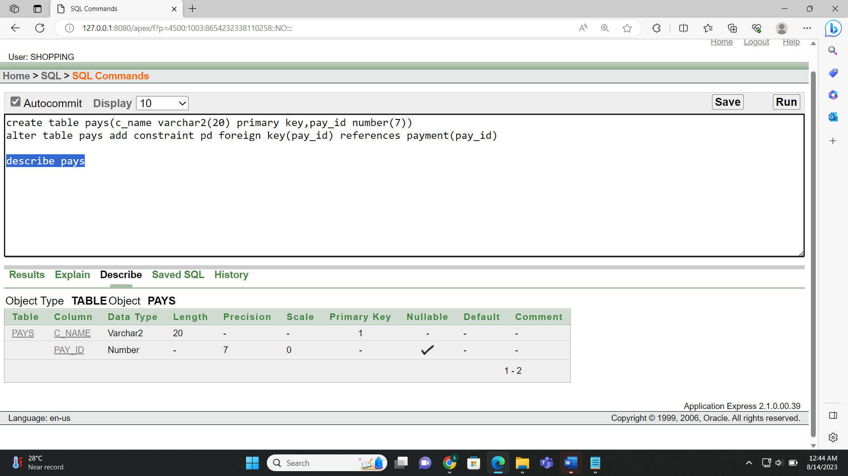



**Figure-6.8**

**Store table creation:**

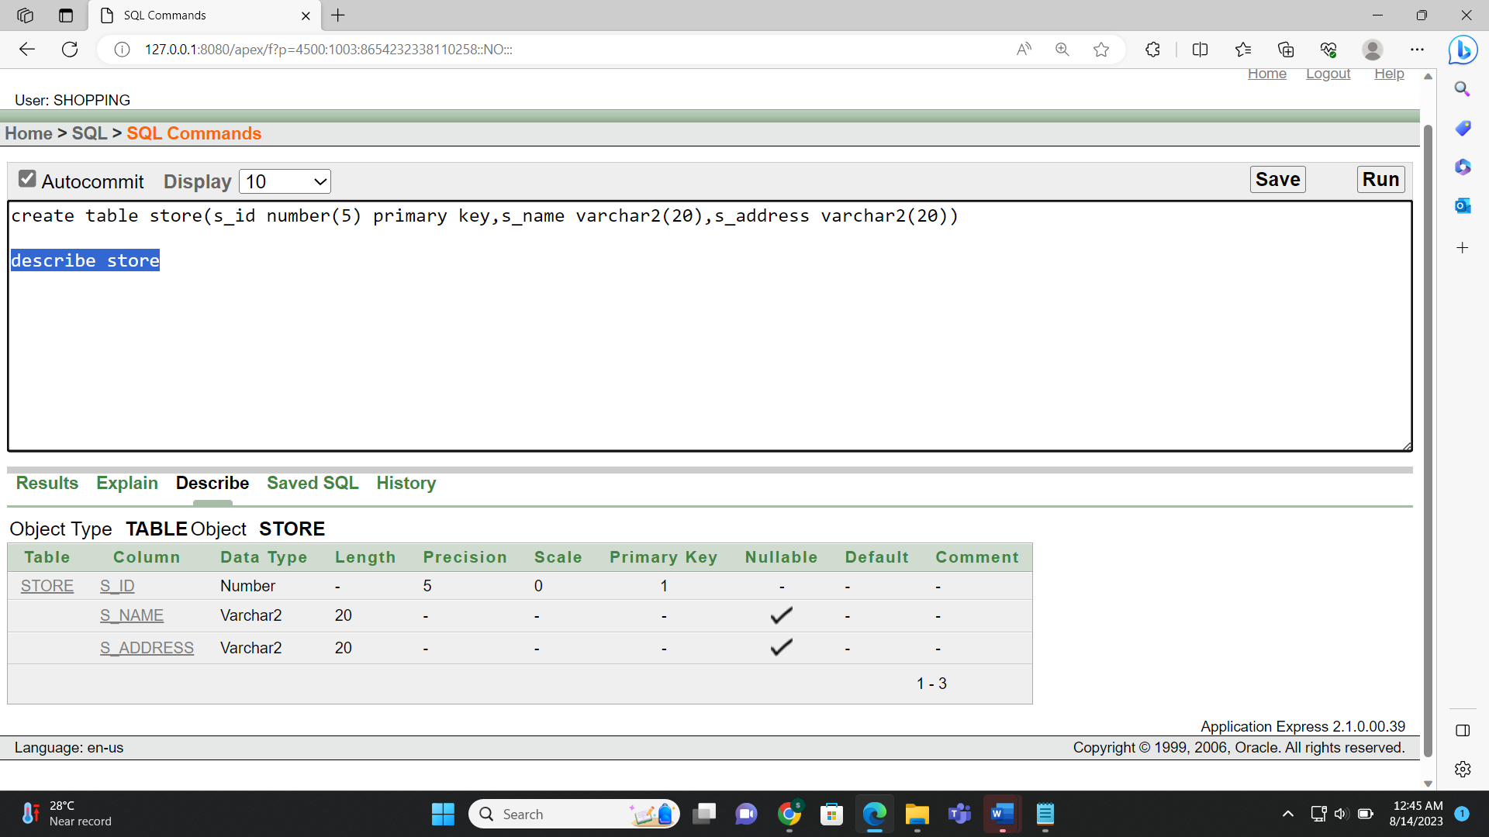

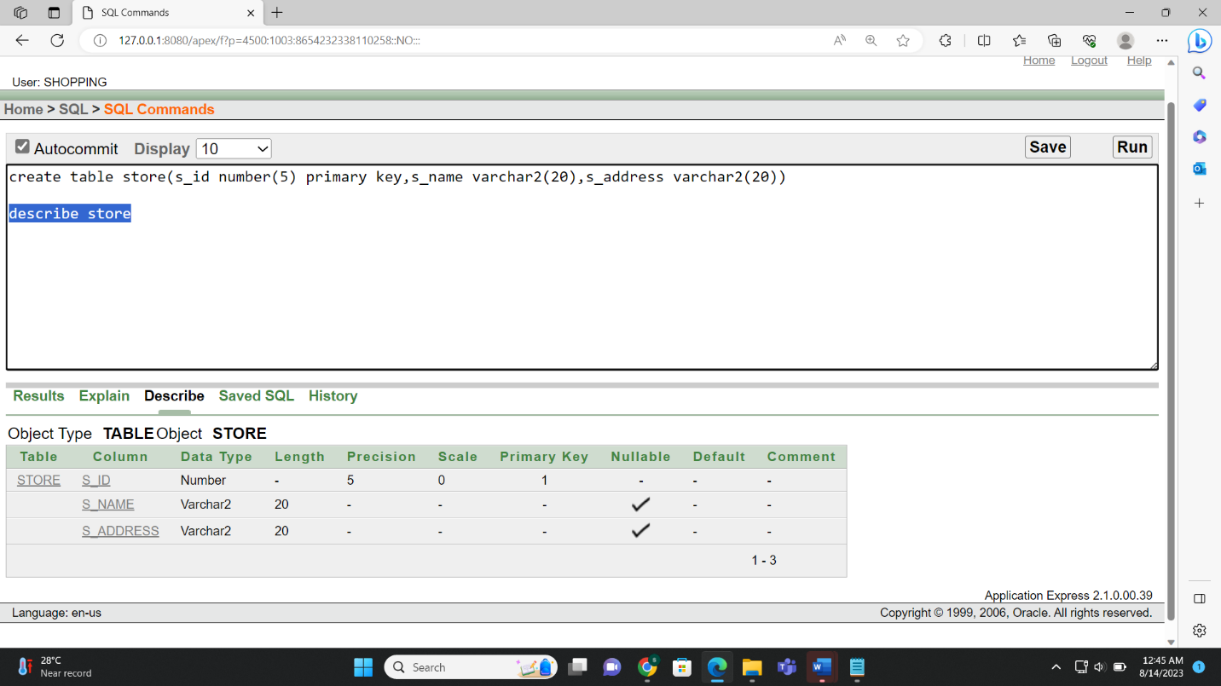

**Figure-6.9**

**Order_From_Store table creation:**

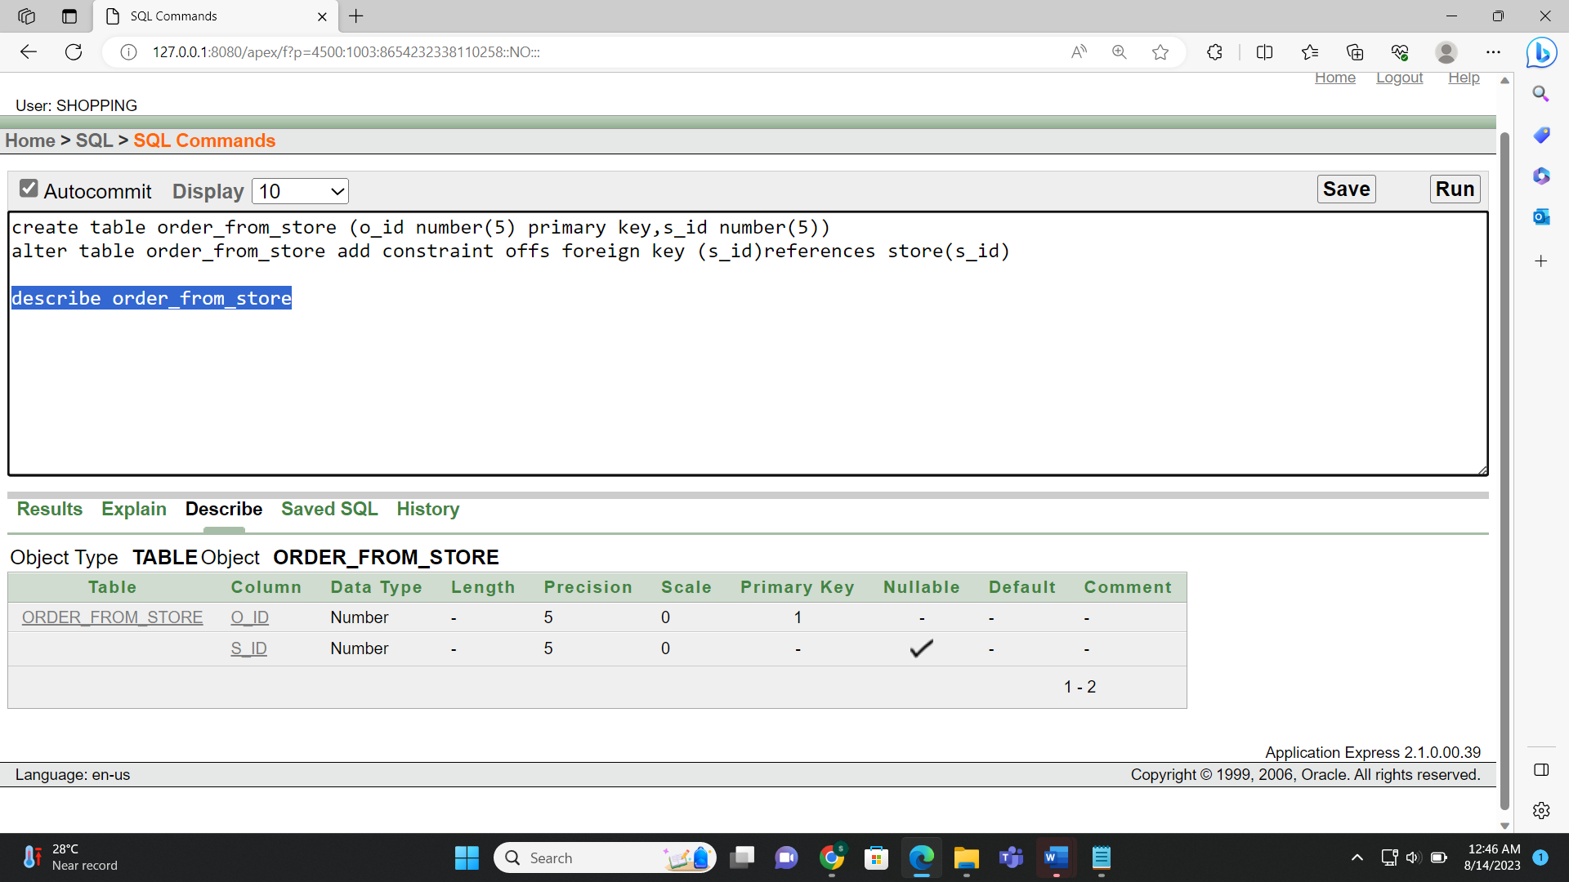



**Figure-6.10**

**Product table creation:**

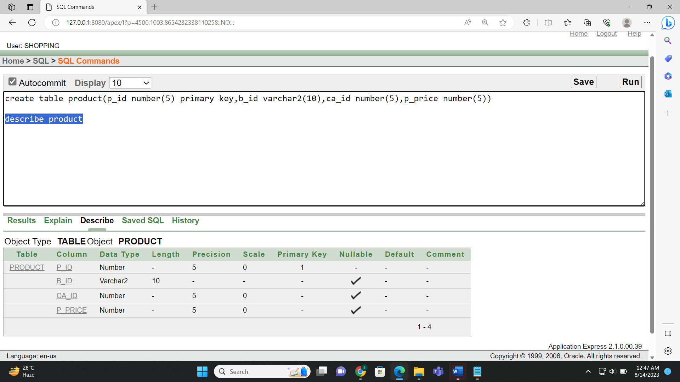



**Figure-6.11**

**Delivers table creation:**

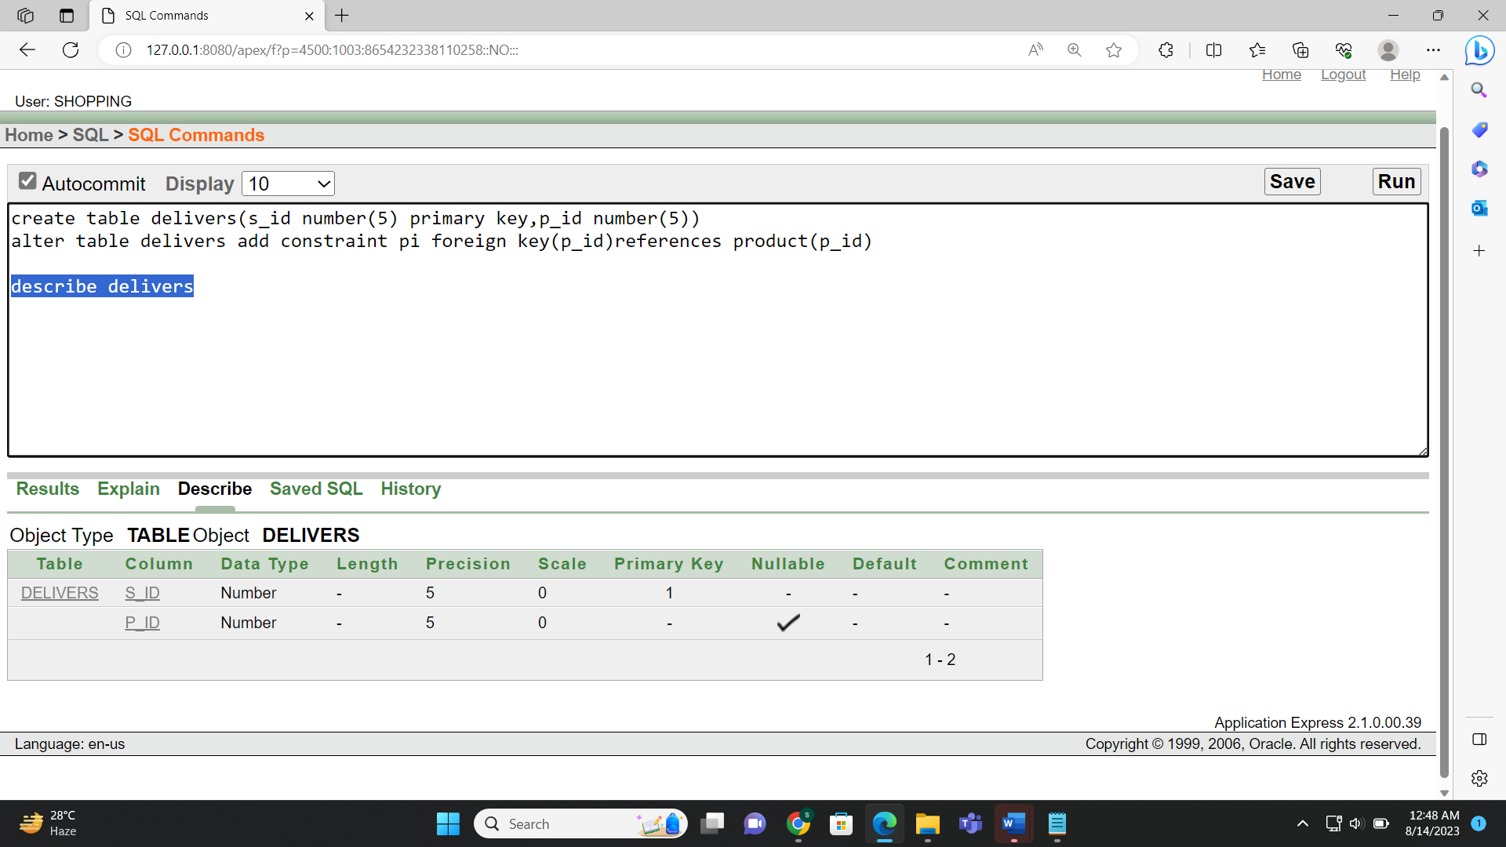



**Figure-6.12**

**Administrator table creation:**

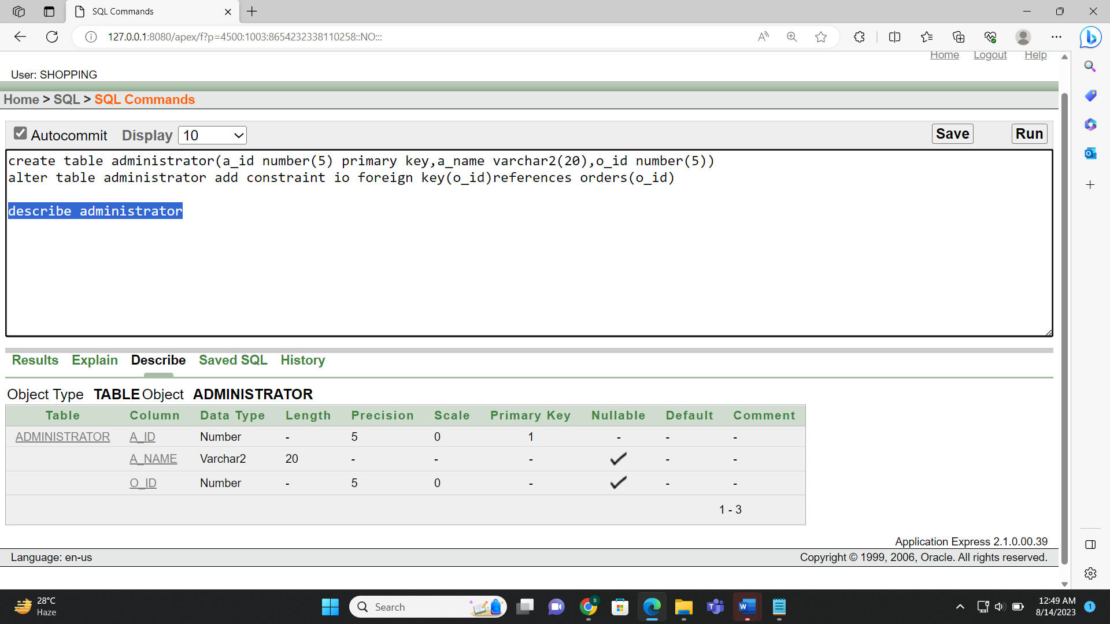



**Figure-6.13**

**Observes table creation:**

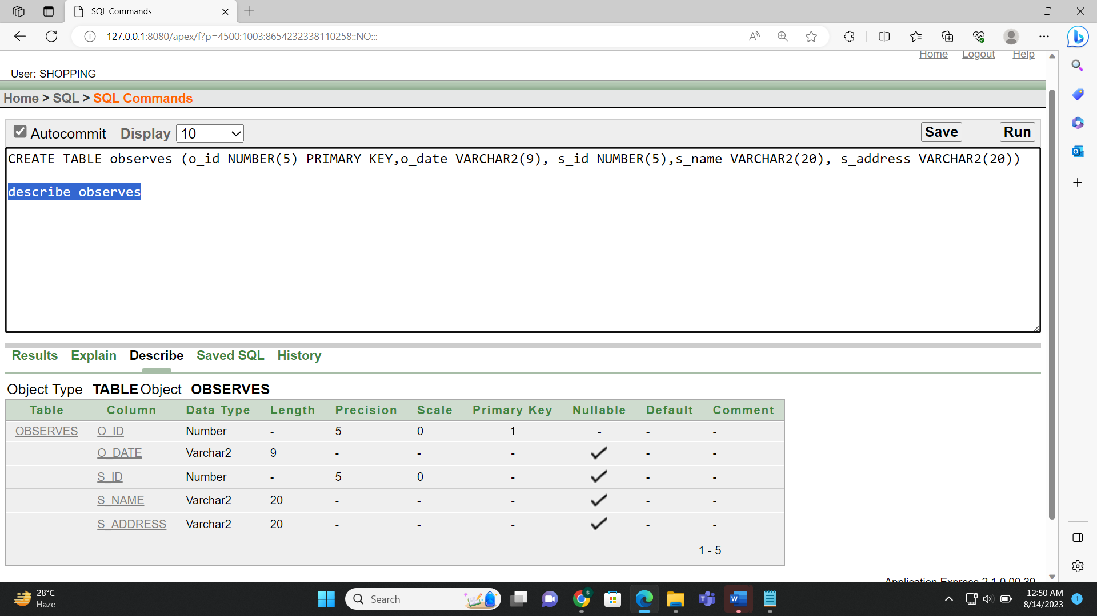



**7.Value Insertion**

**Figure-7.1**

**Customer table value insertion:**

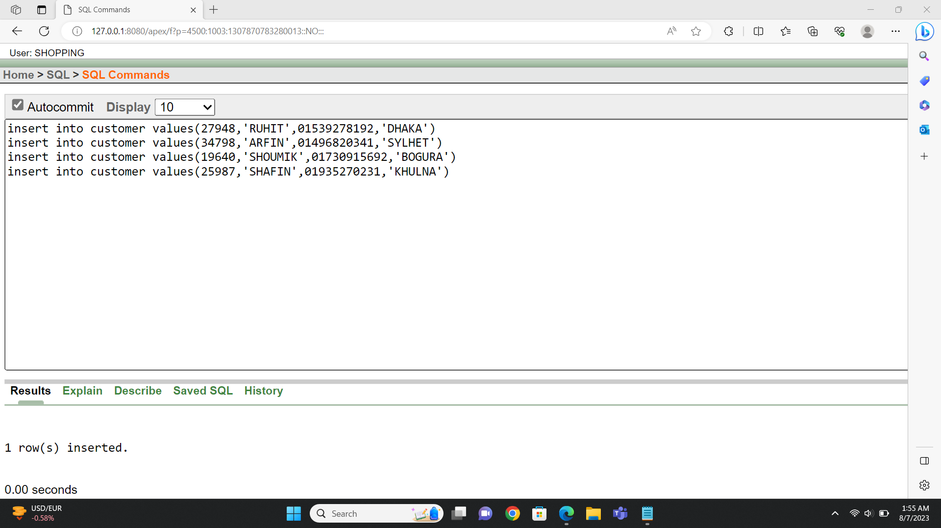

**Figure-7.2**

**Customer table value showing:**

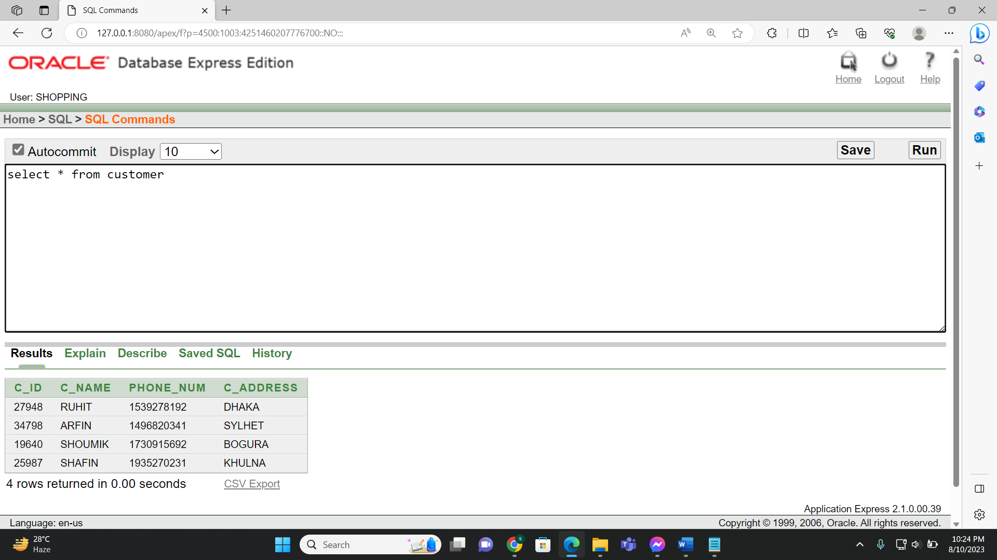

**Figure-7.3**

**Orders table value insertion:**

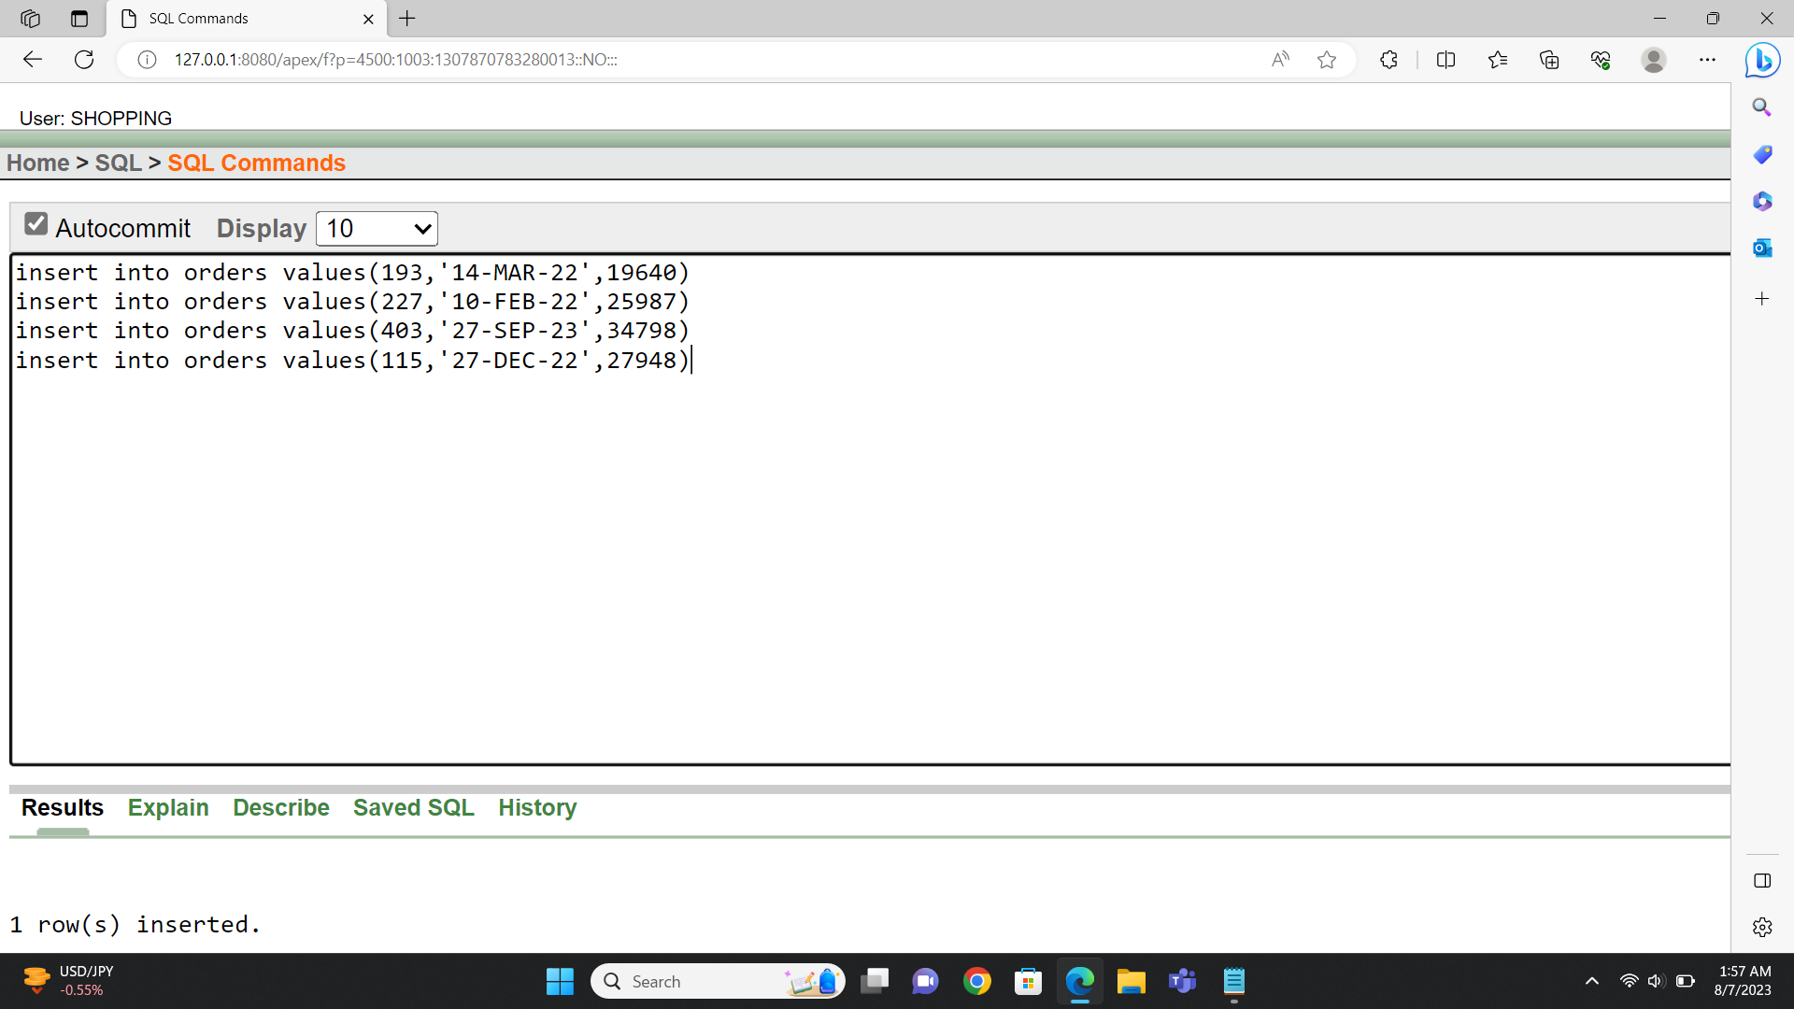

**Figure-7.4**

**Orders table value showing:**

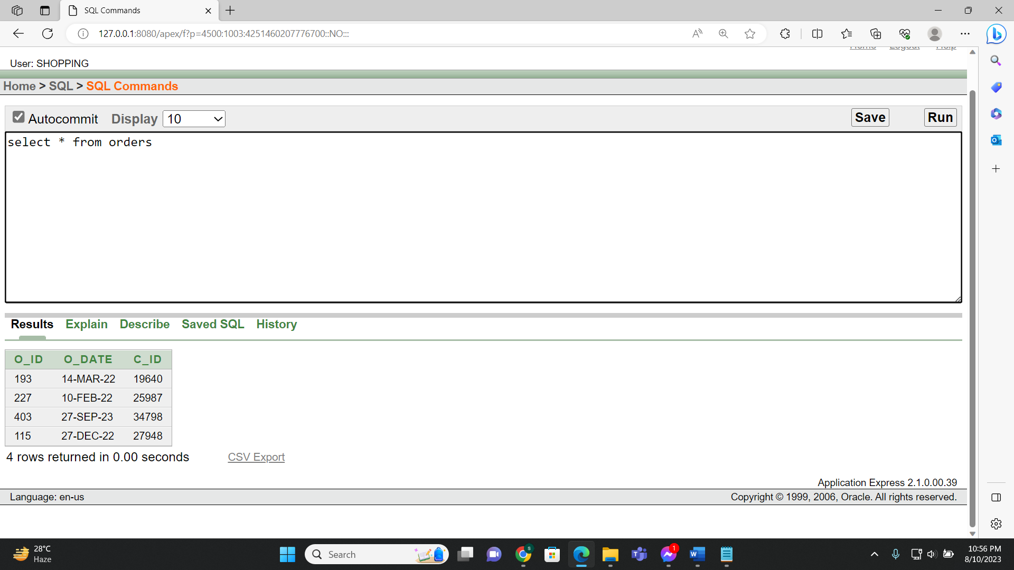

**Figure-7.5**

**Dates table value insertion:**

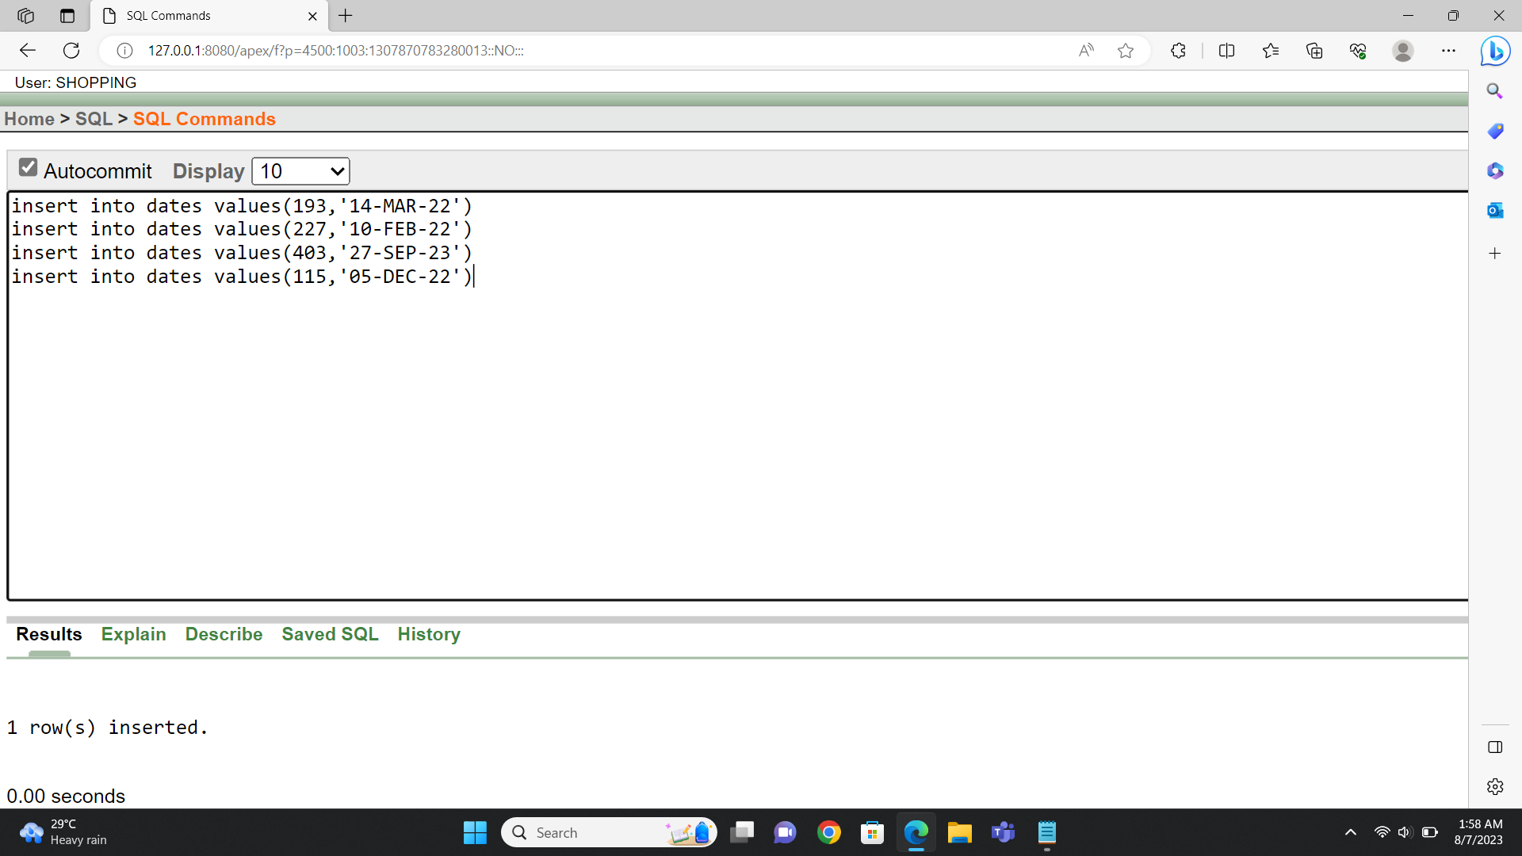

**Figure7.6**

**Dates table value showing:**

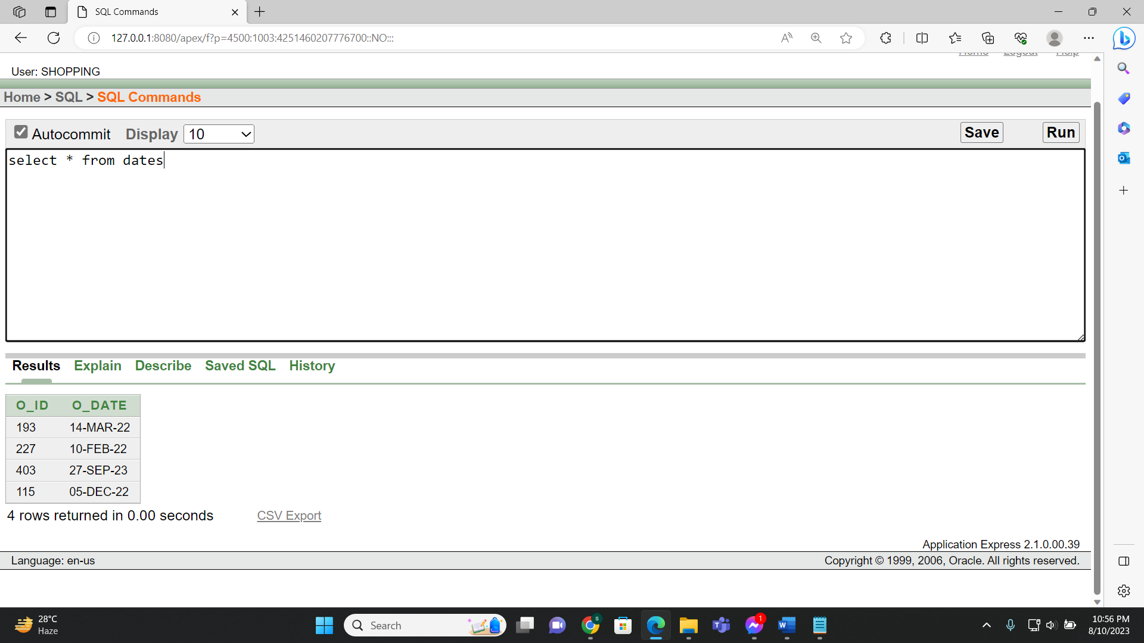

**Figure7.7**

**Details table value insertion:**

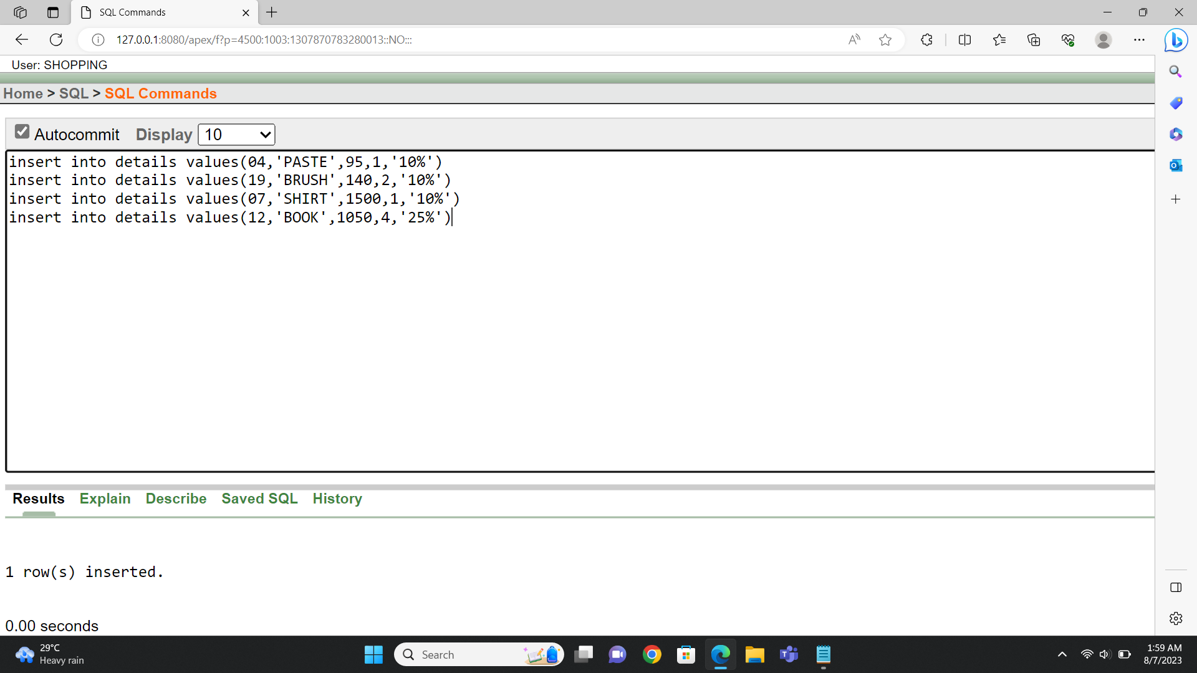

**Figure-7.8**

**Details table value showing:**

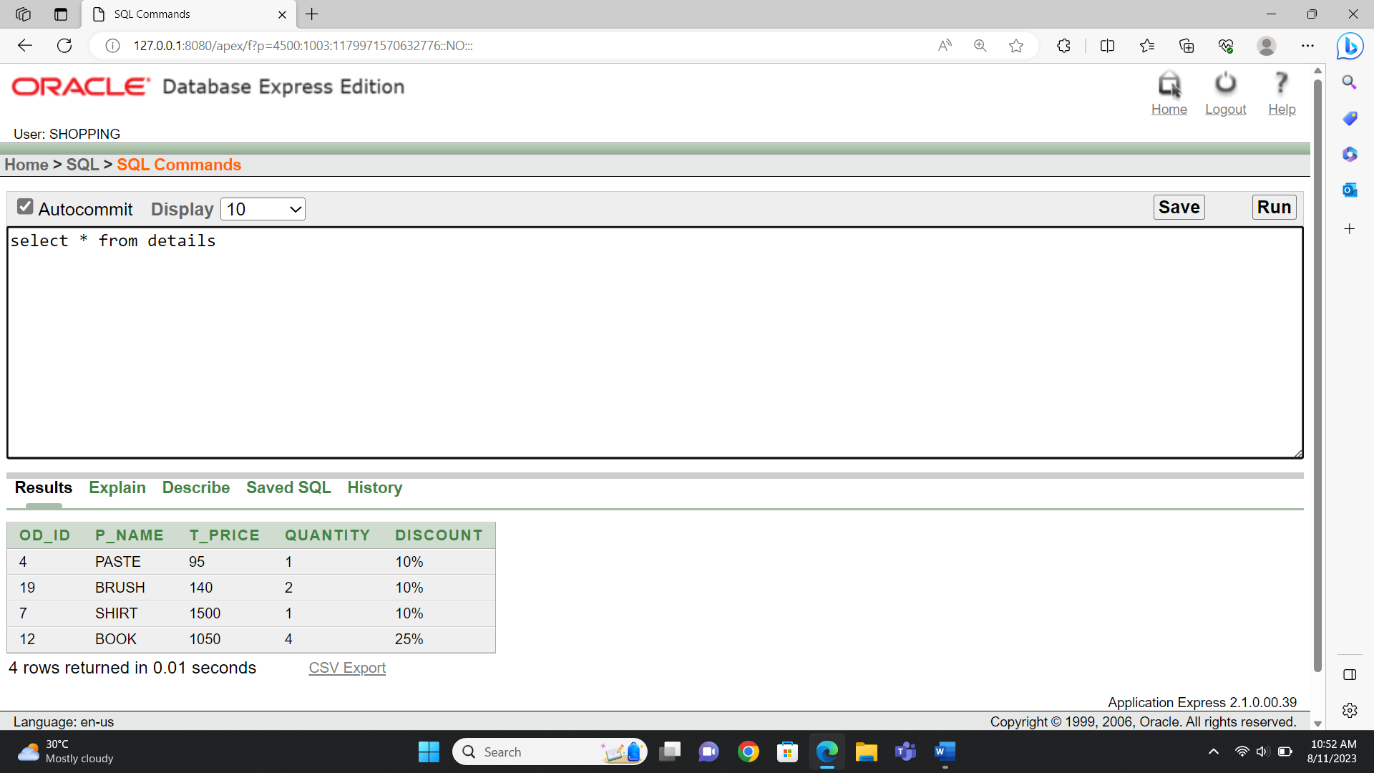

**Figure7.9**

**Has table value insertion:**

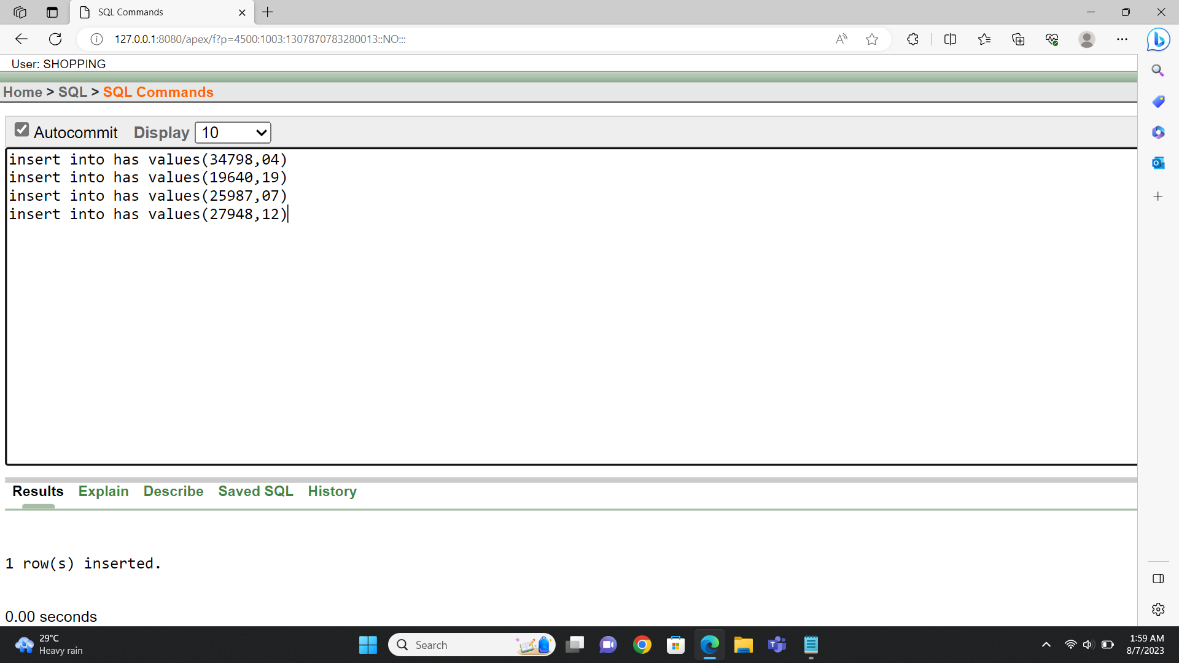

**Figure-7.10**

**Has table value showing:**

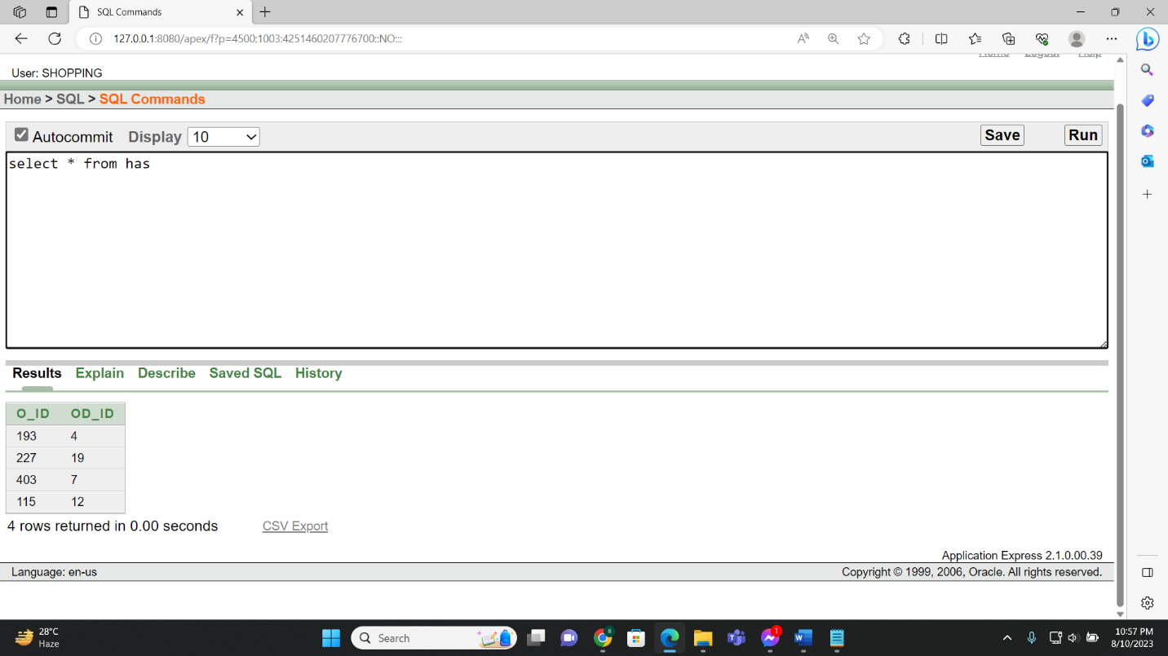

**Figure7.11**

**Payment table value insertion:**

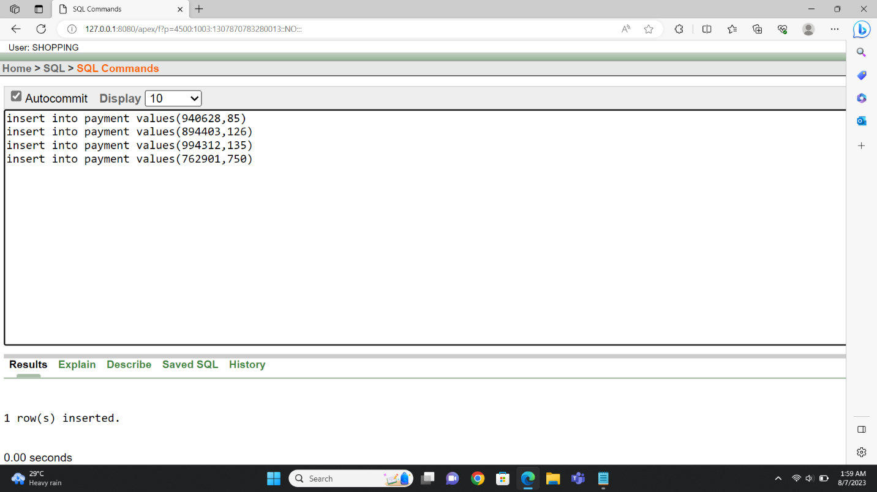

**Figure-7.12**

**Payment table value showing:**

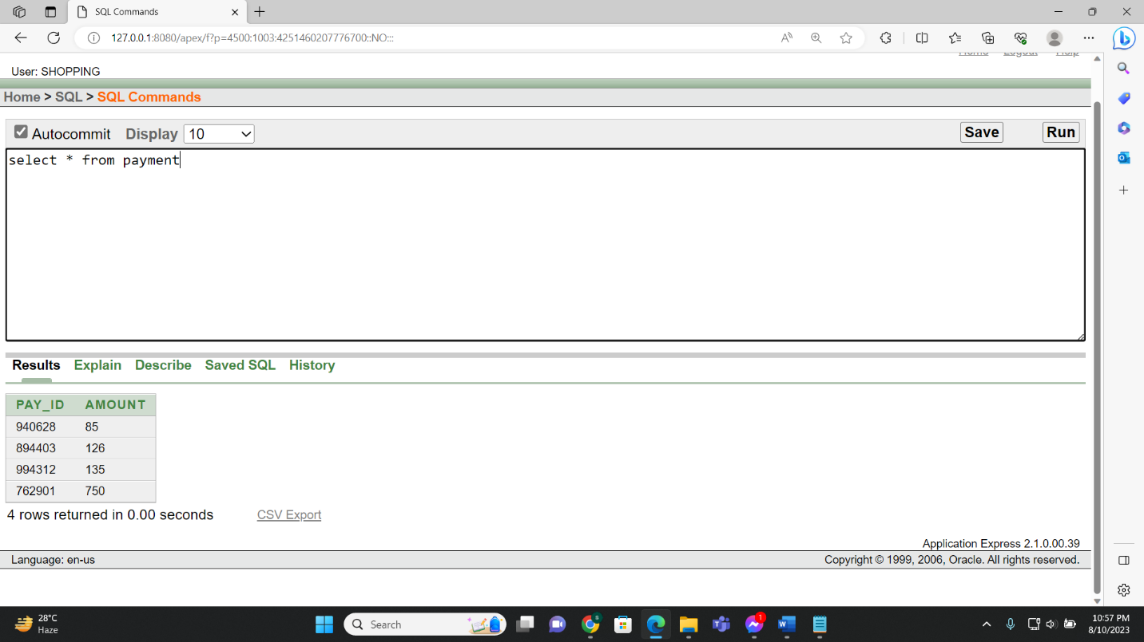

**Figure-7.13**

**Pays table value insertion:**

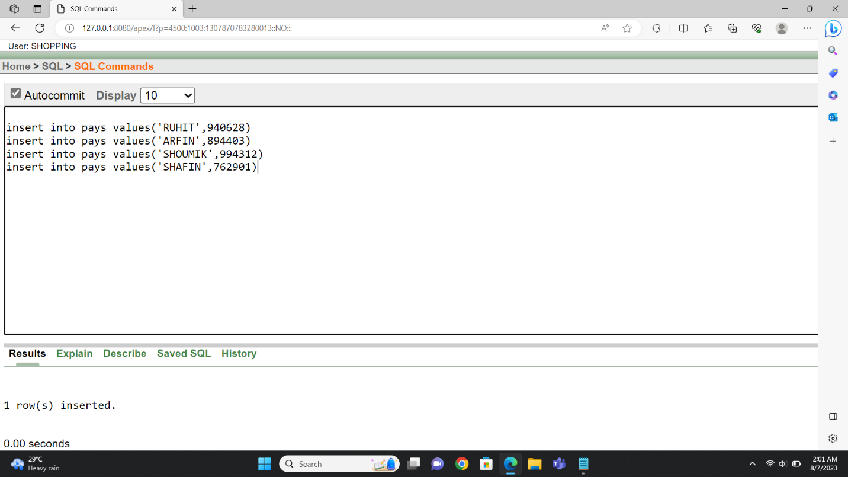

**Figure7.14**

**Pays table value showing:**

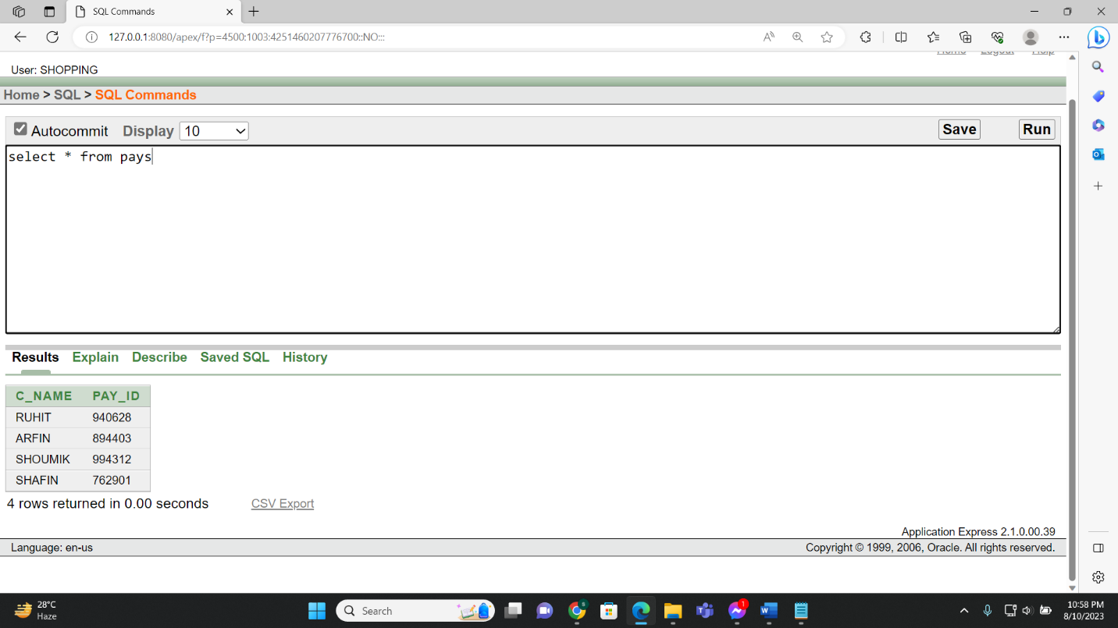

**Figure-7.15**

**Store table value insertion:**

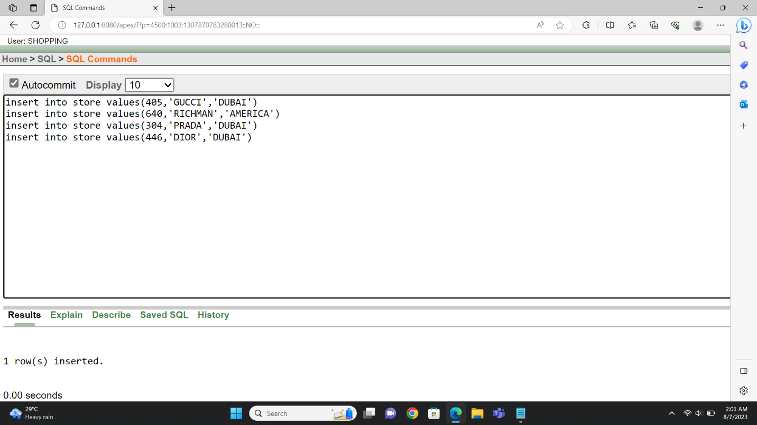

**Figure-7.16**

**Store table value showing:**

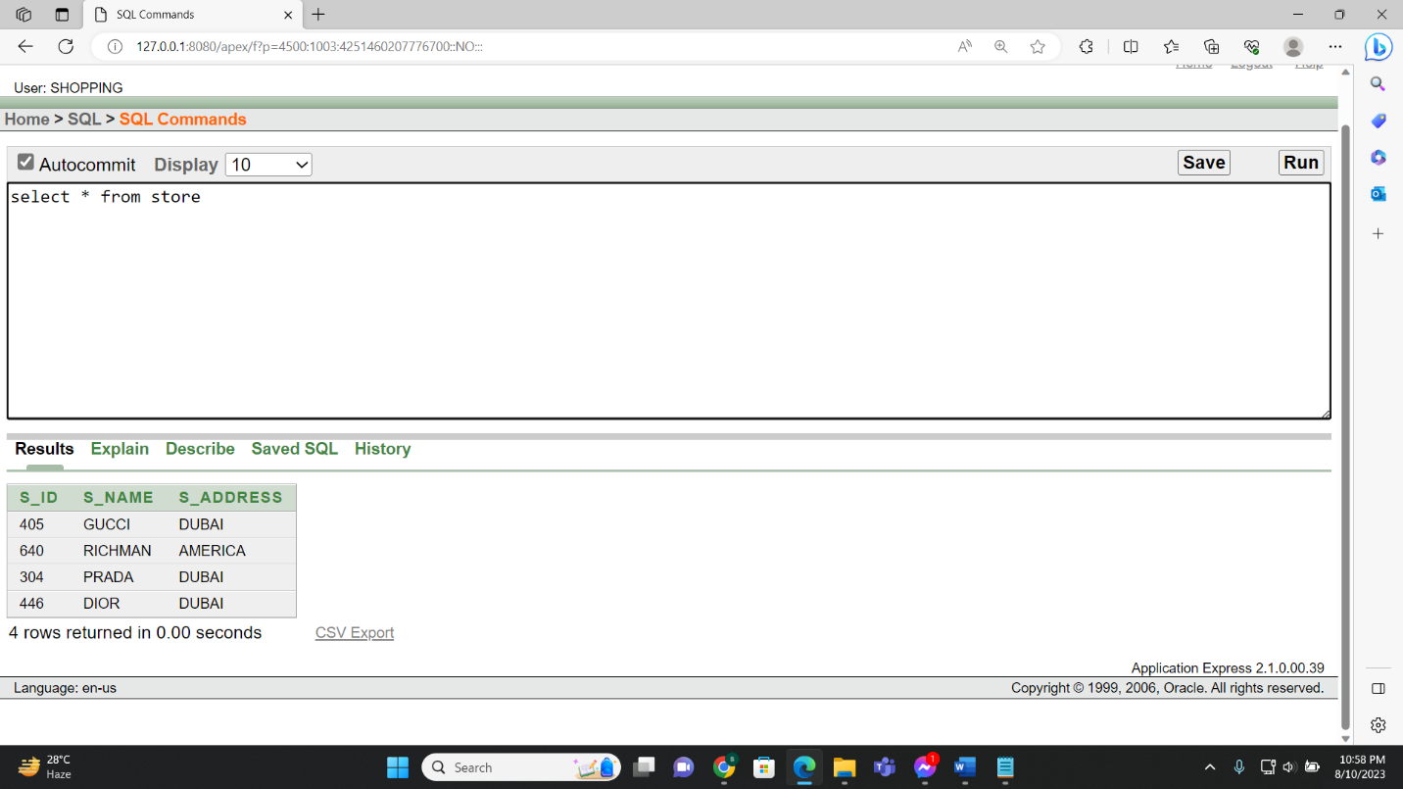

**Figure-7.17**

**Order_from_store table value insertion:**

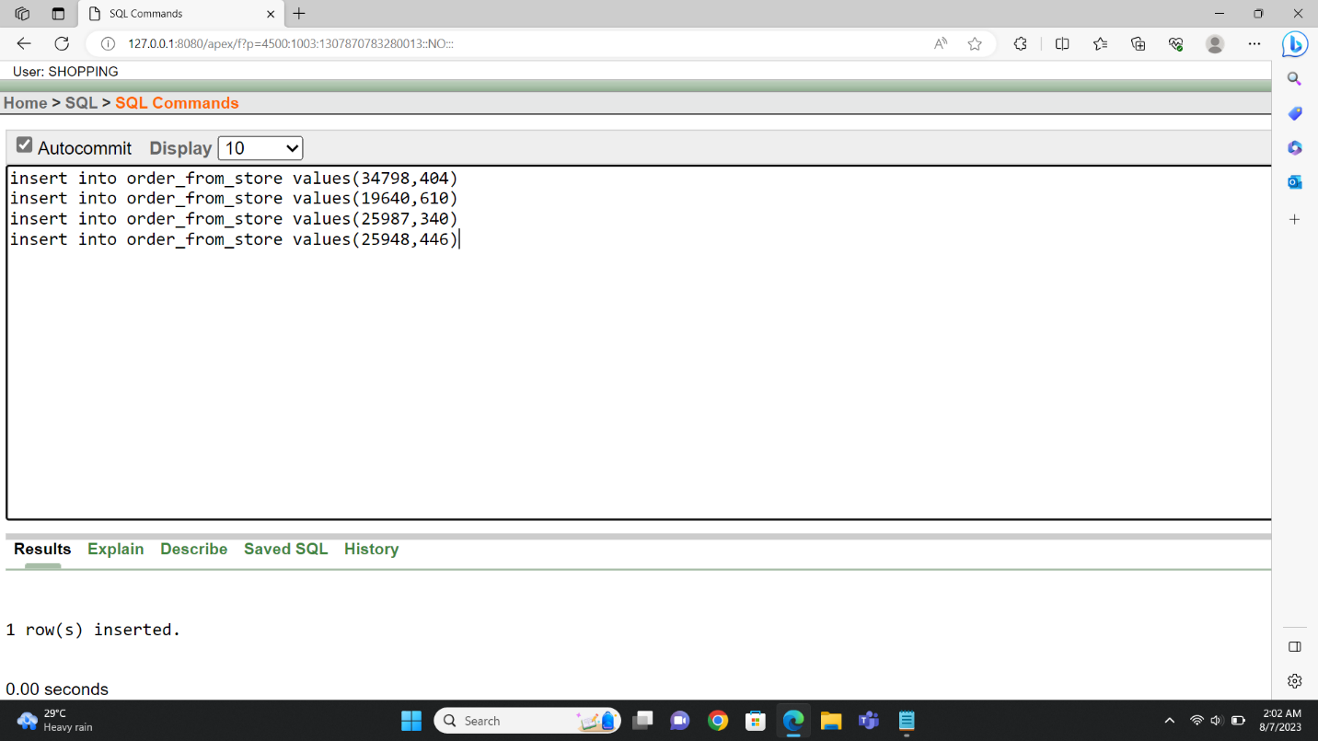

**Figure-7.18**

**Order_from_store table value showing:**

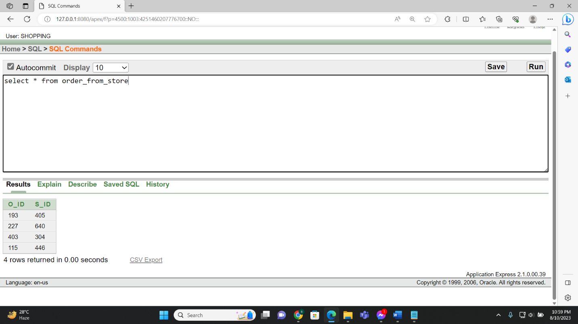

**Figure-7.19**

**Product table value insertion:**

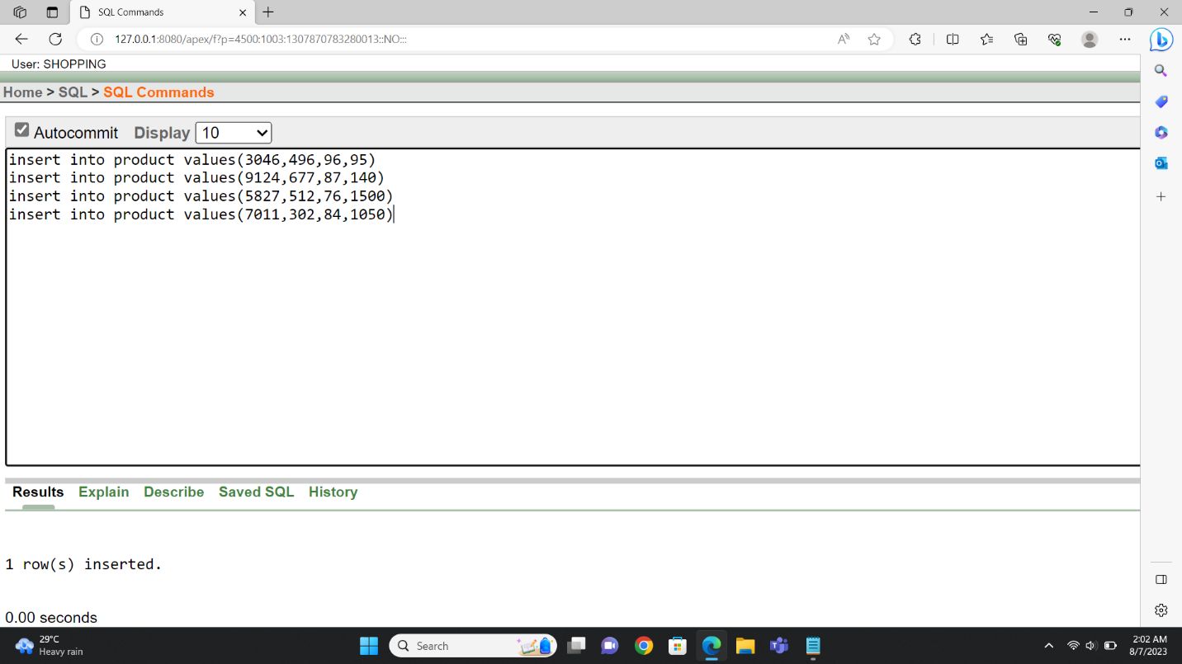

**Figure-7.20**

**Product table value showing:**

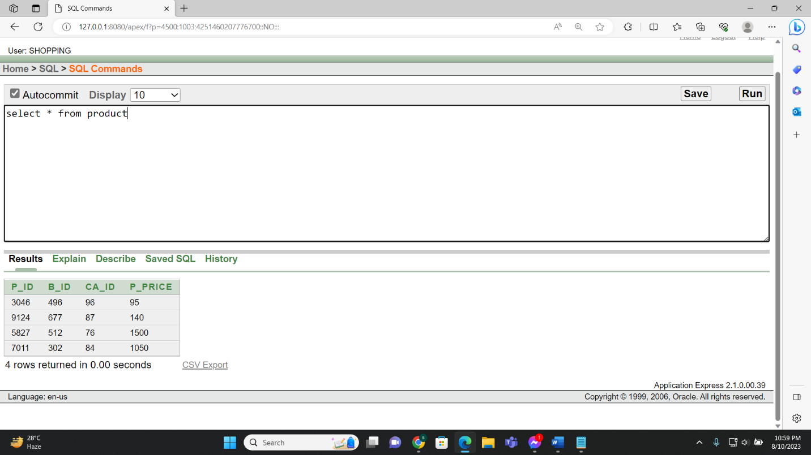

**Figure-7.21**

**Delivers table value insertion:**

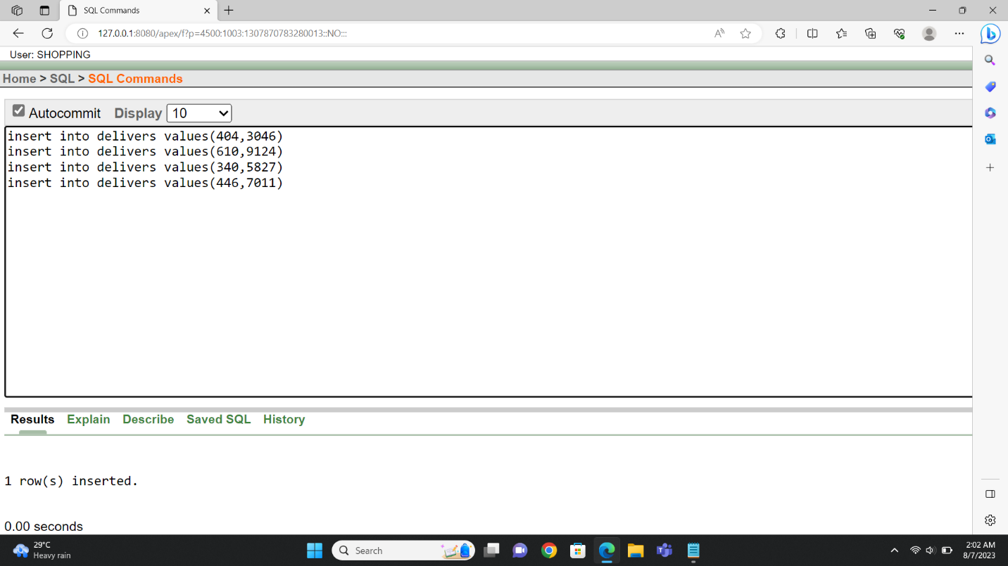

**Figure-7.22**

**Delivers table value showing:**

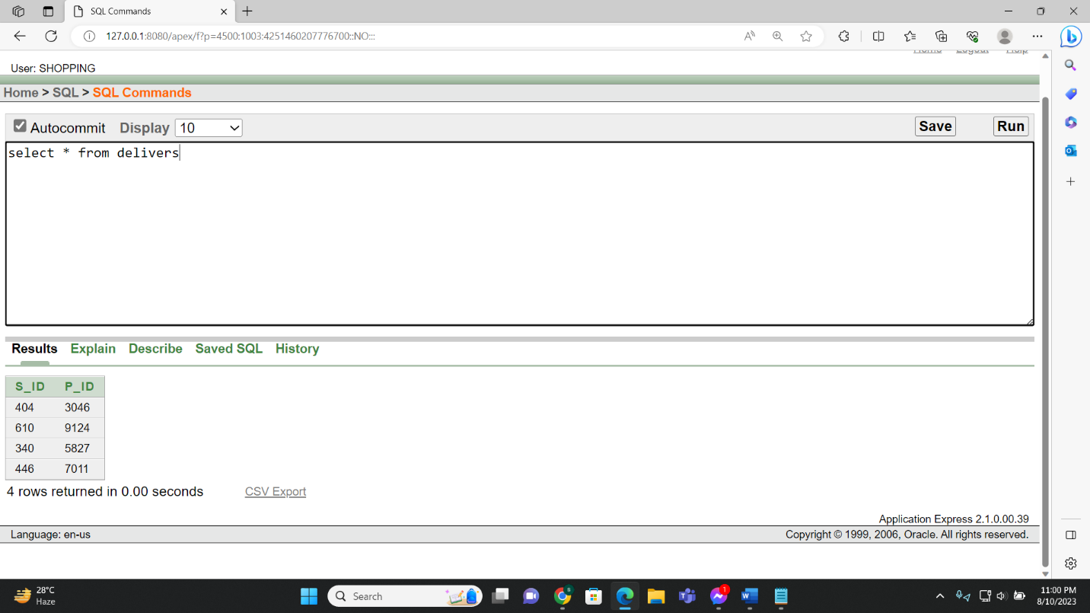

**Figure-7.23**

**Administrator table value insertion:**

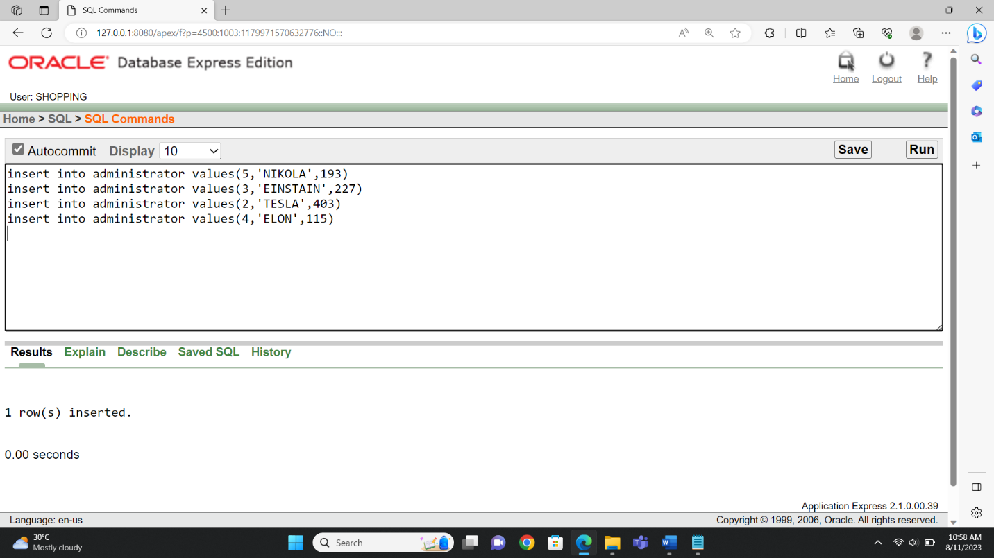

**Figure-7.24**

**Administrator table value showing:**

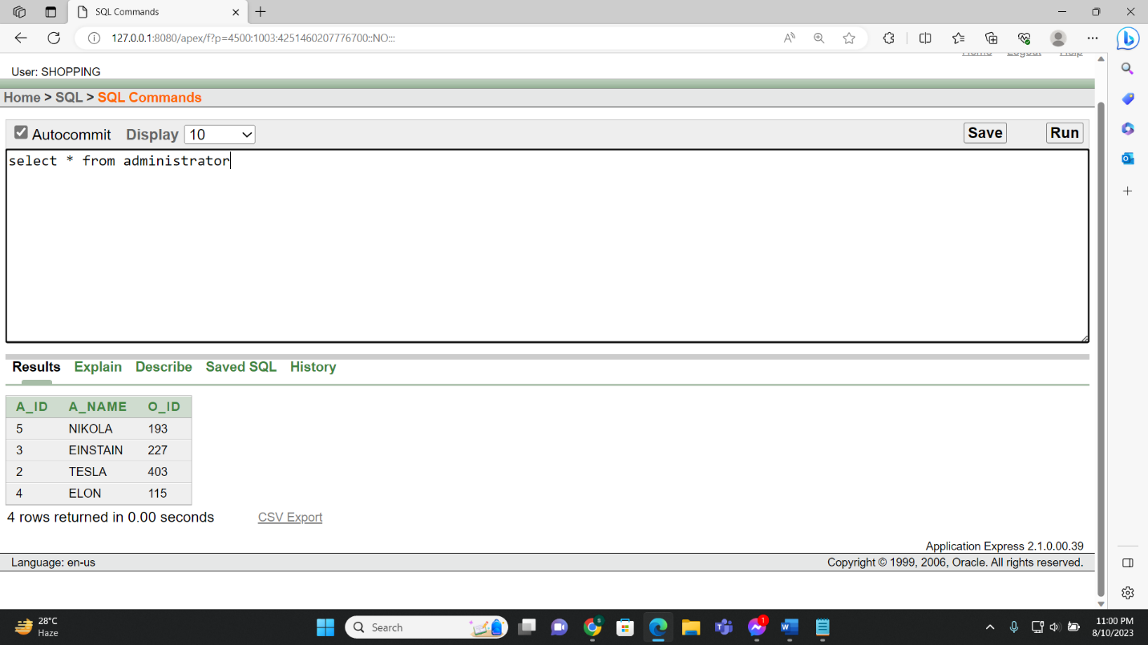

**Figure-7.25**

**Observes table values insertion:**

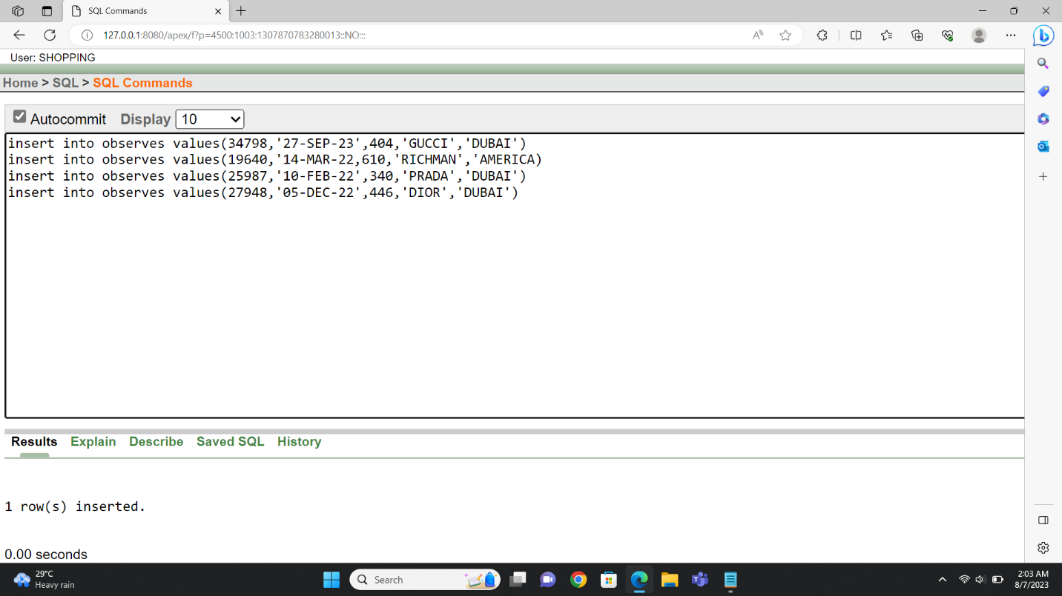

**Figure-7.26**

**Observes table value showing:**

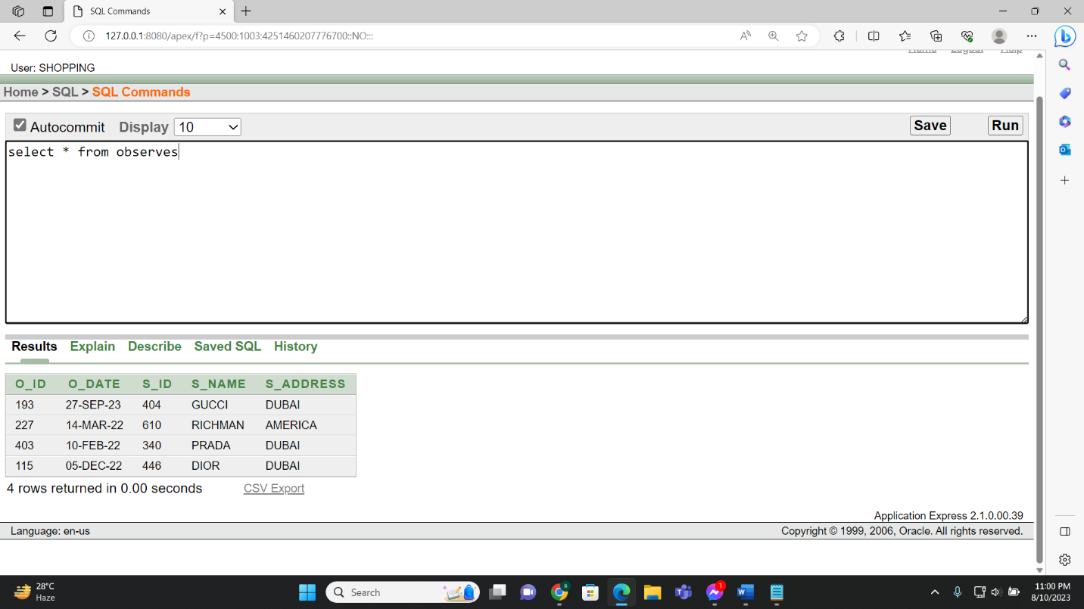

**8.Query Test:**

**Simple Query:**

* Display c_id, c_name of customers from customer table where name is ‘Arfin’.

**Figure-8.1:**

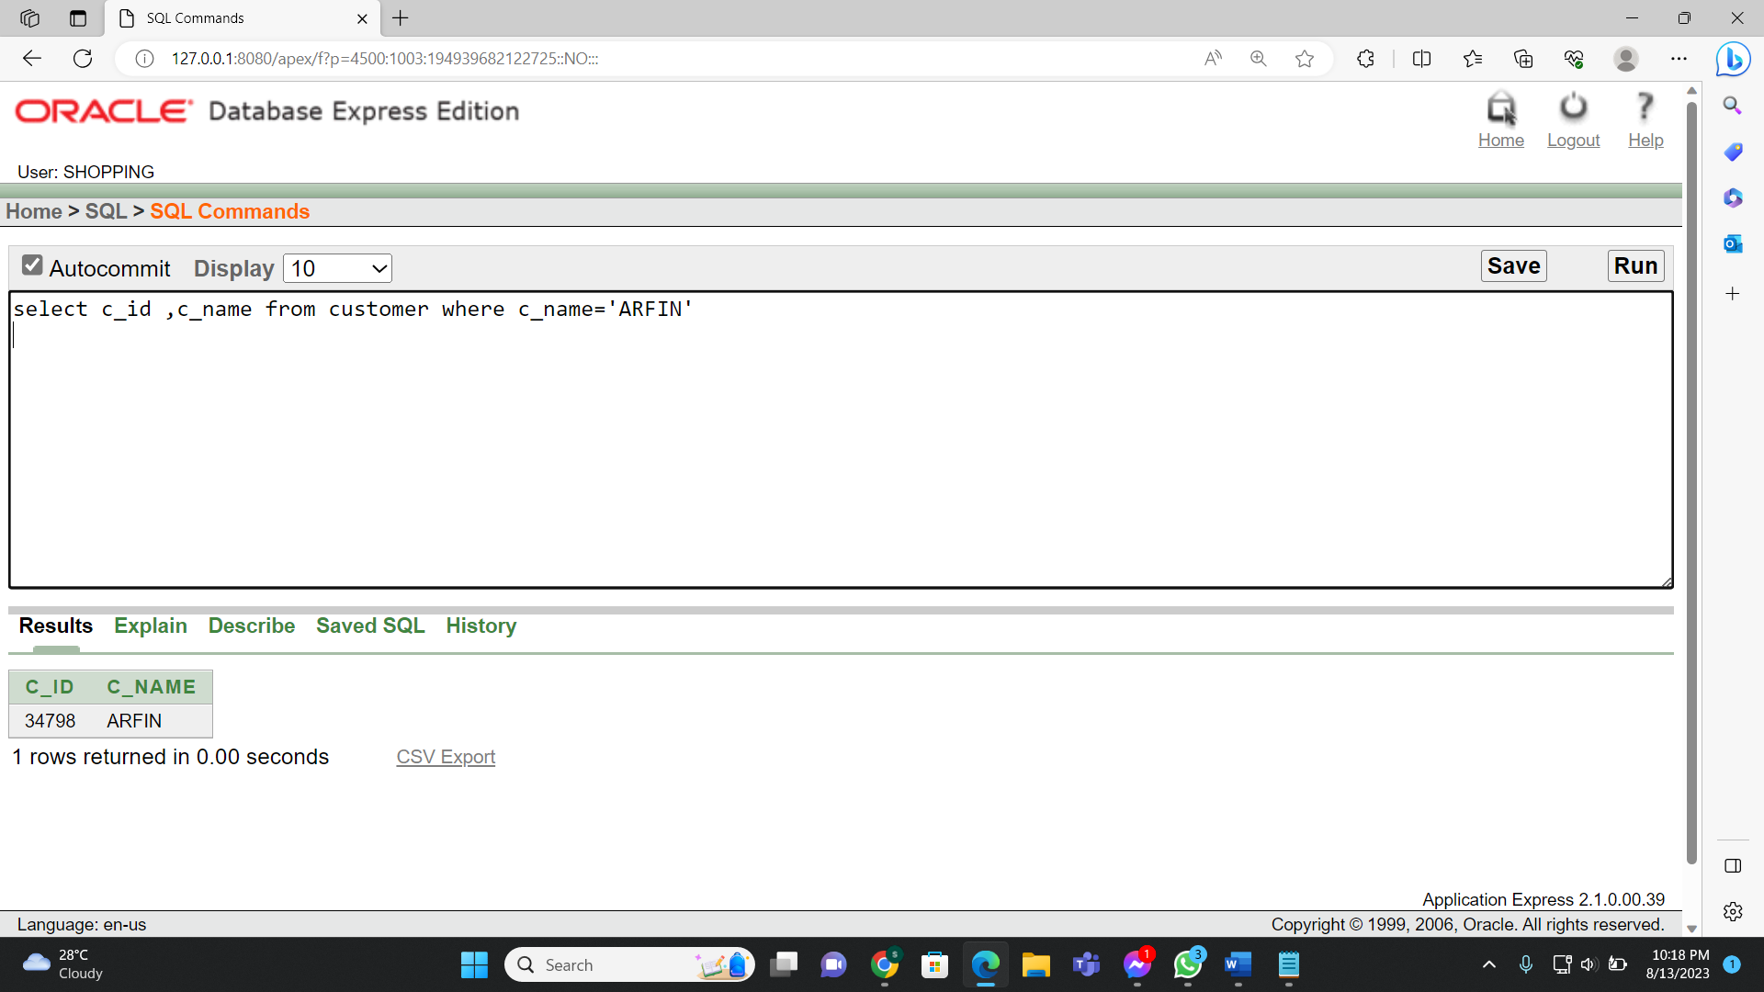

**Figure-8.2:**

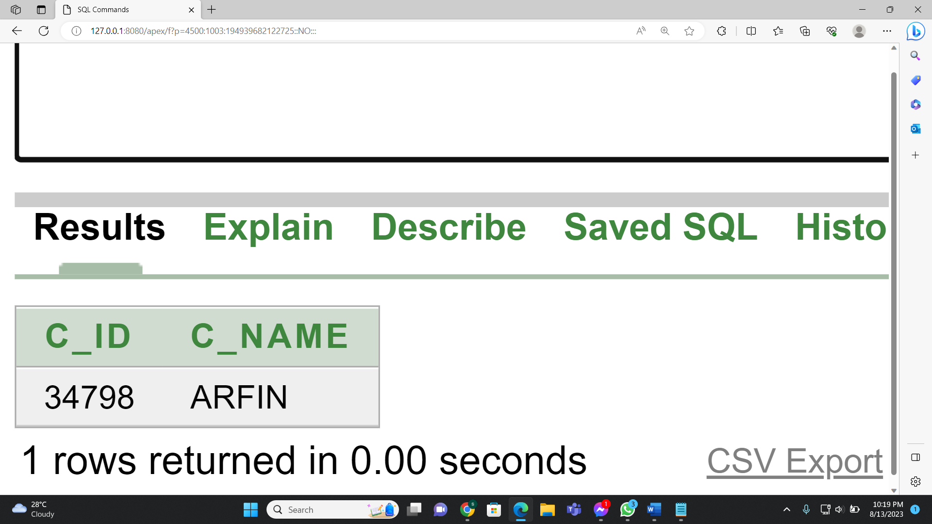

**Single row subquery:**

* Display product id and product price from product where product price is grater then Categorie id 84 from product

**Figure-8.3**

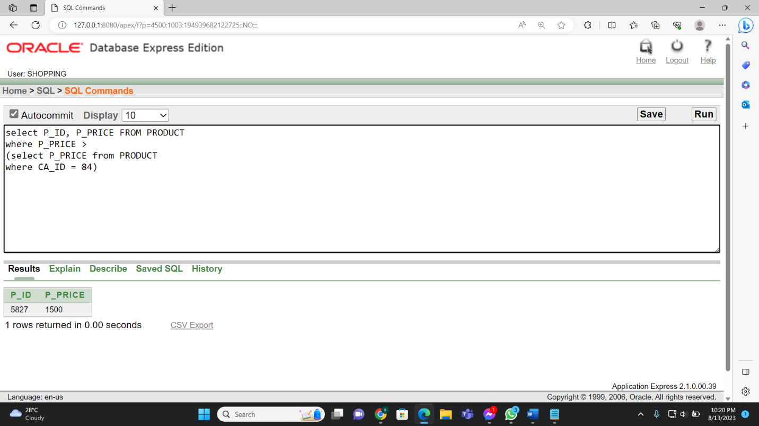

**Figure-8.4:**

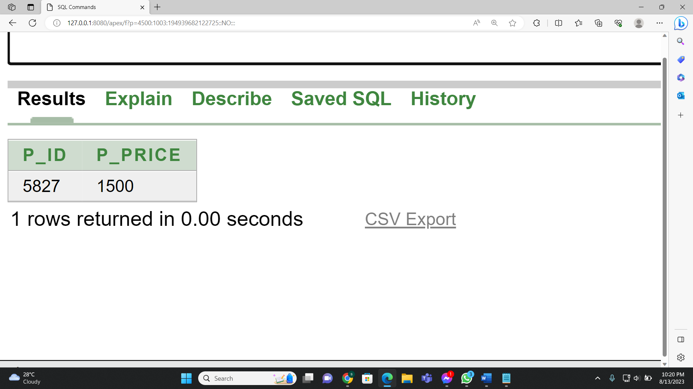

**Multiple Row Sub Query:**

* Display store name and store id where order id betweeen 115 to 227.

**Figure-8.5:**

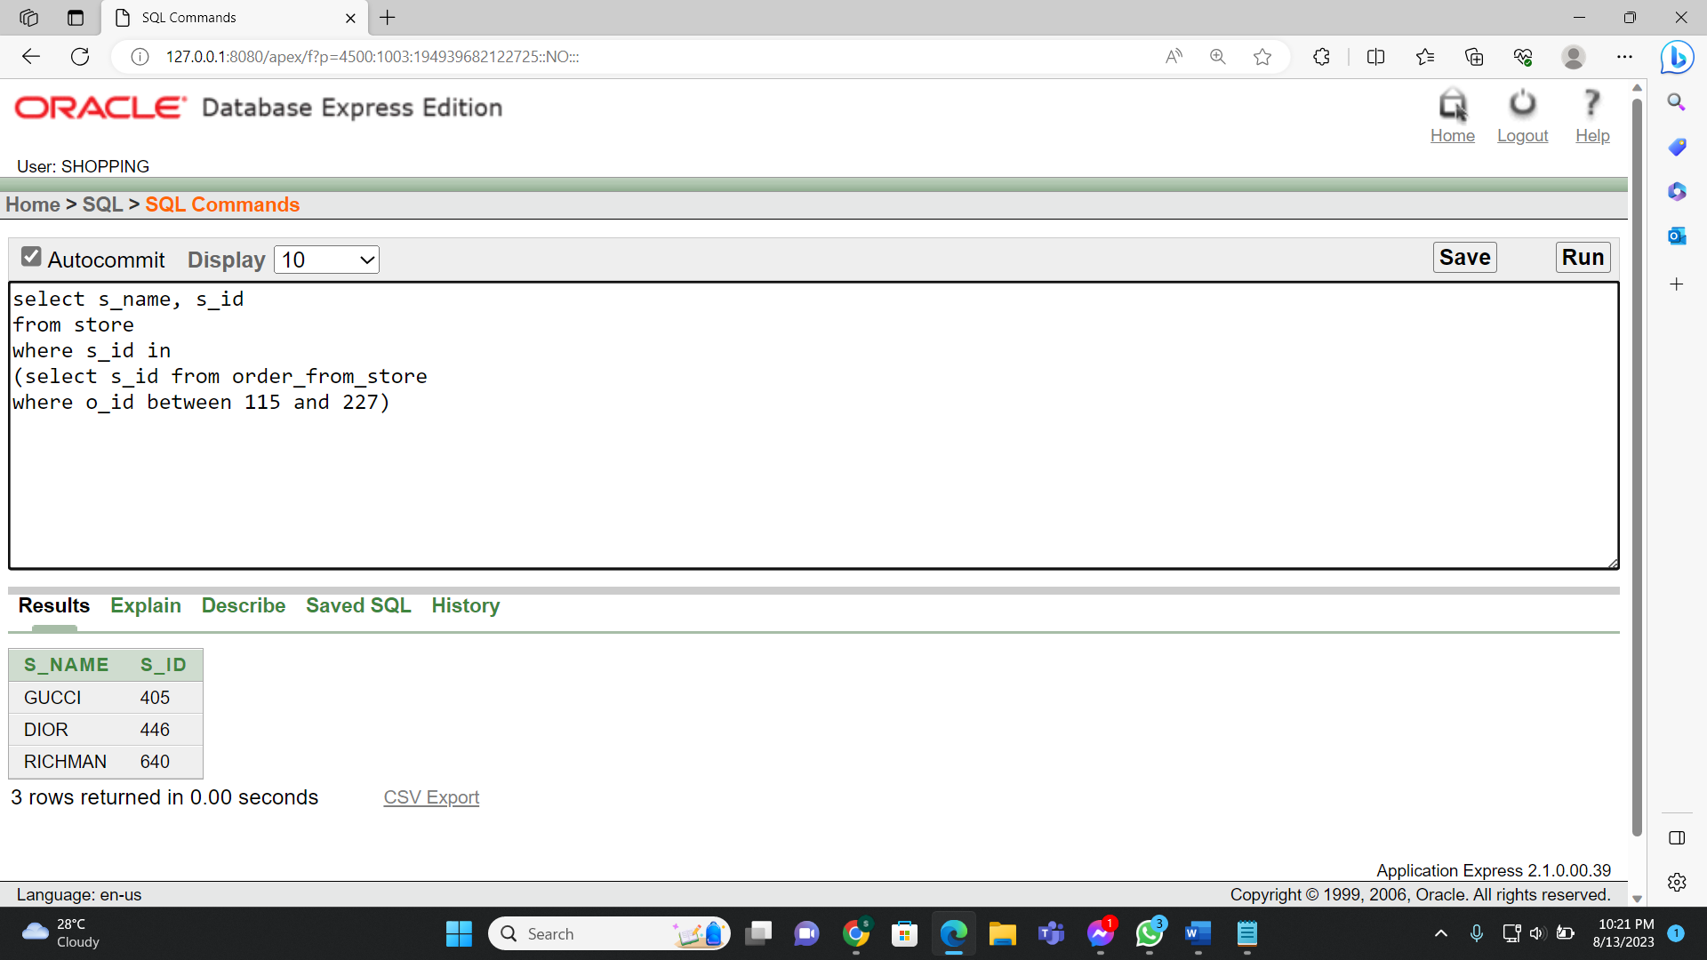

**Figure-8.6:**

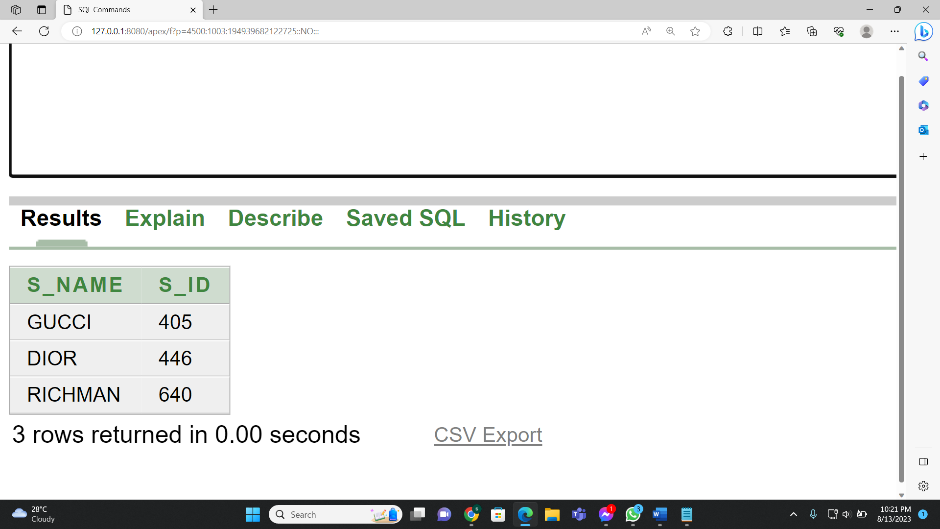

**Self-Join:**

* Display product name, order details id, total price and discount by self-joining from details table by order details id.

**Figure-8.7:**

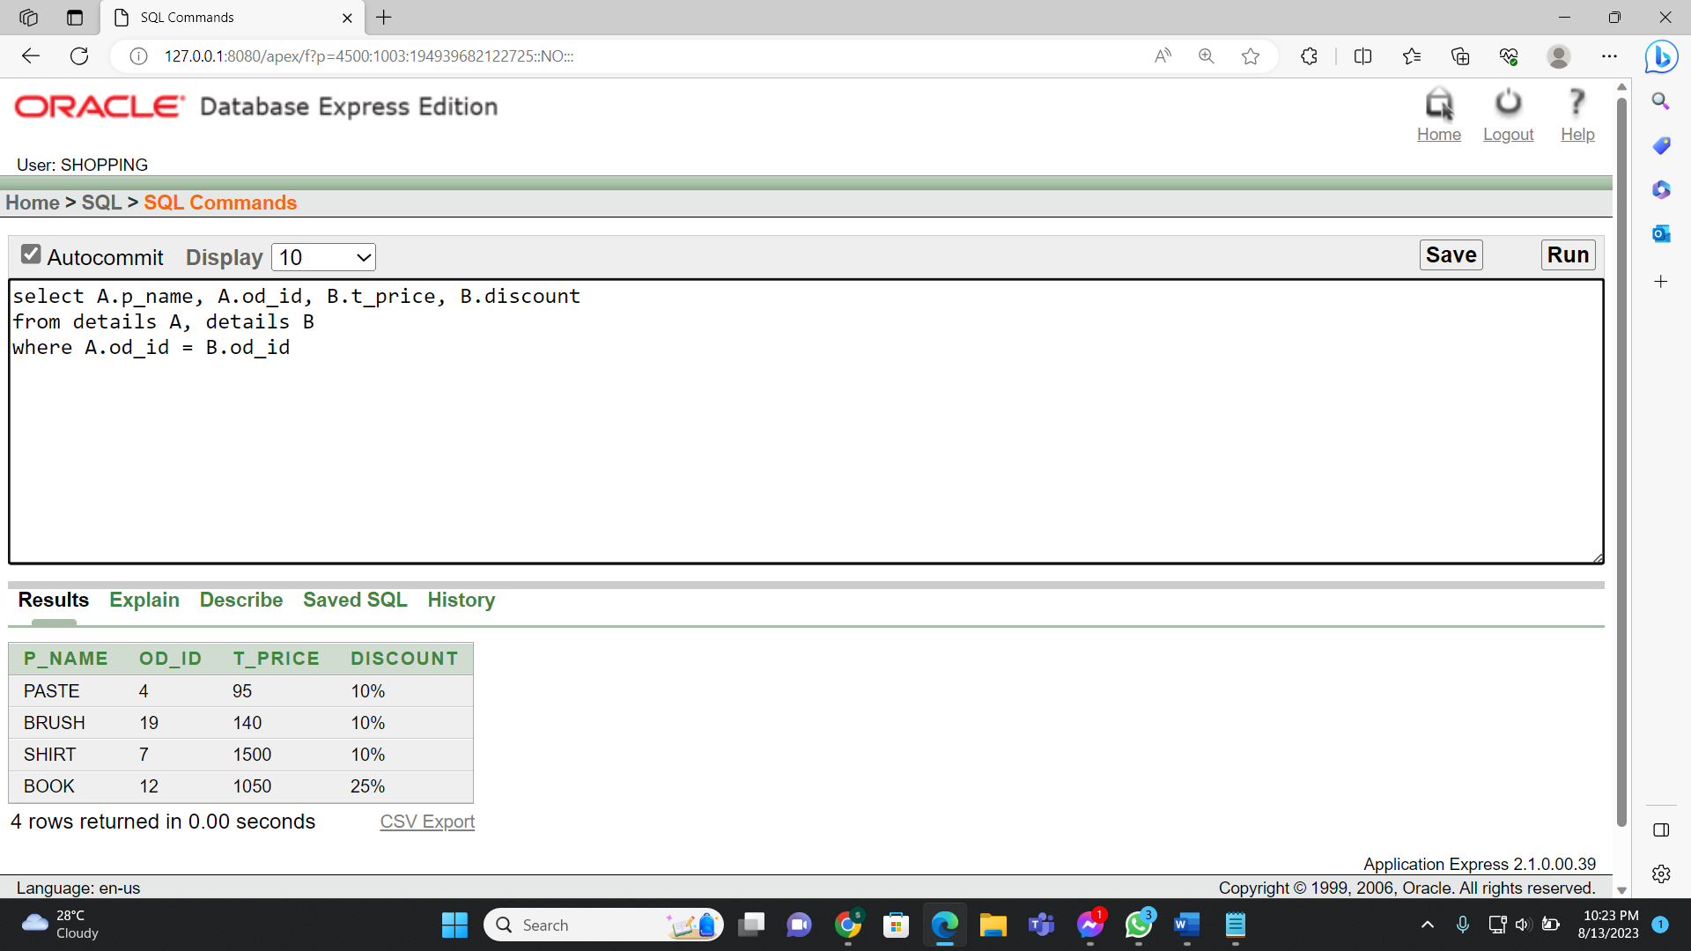

**Figure-8.8:**

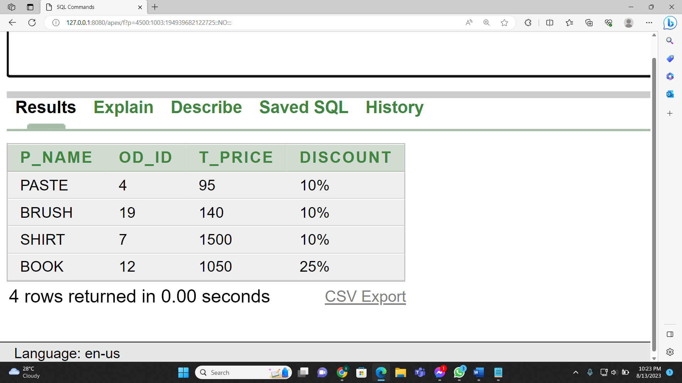

**Equi-join:**

* Display the product id, product price and store id from the product and deliver tables where the product id matches between the two tables.

**Figure-8.9:**

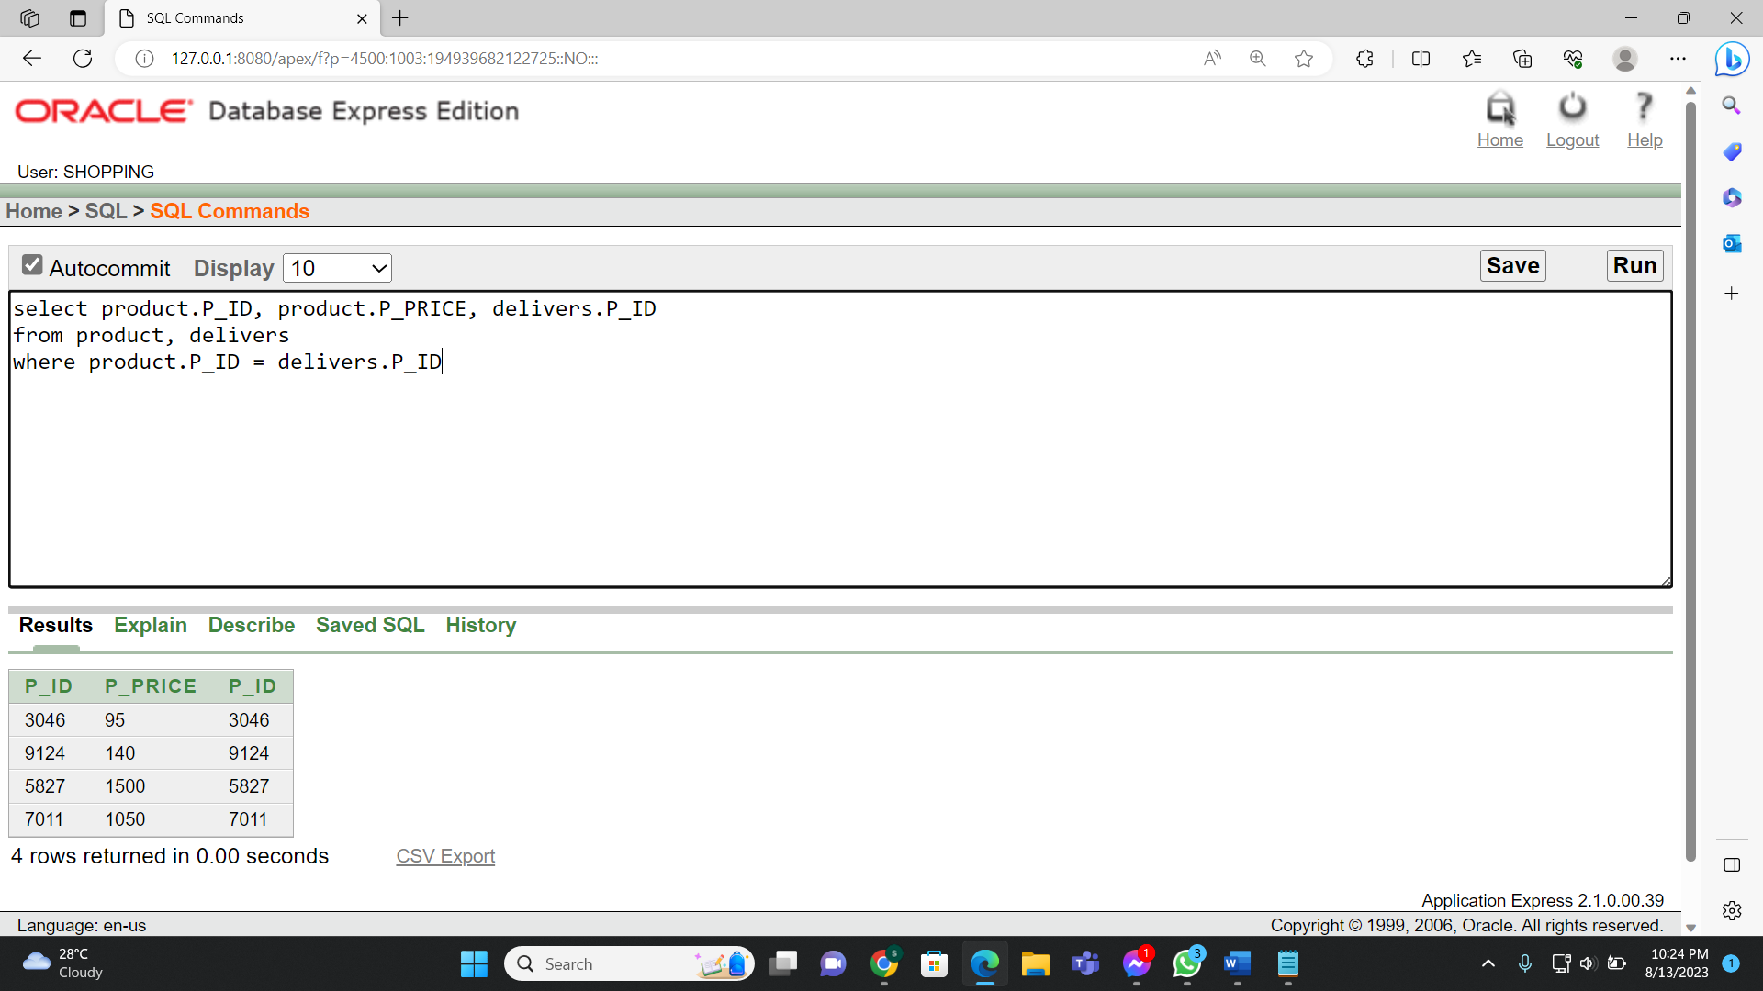

**Figure-8.10:**

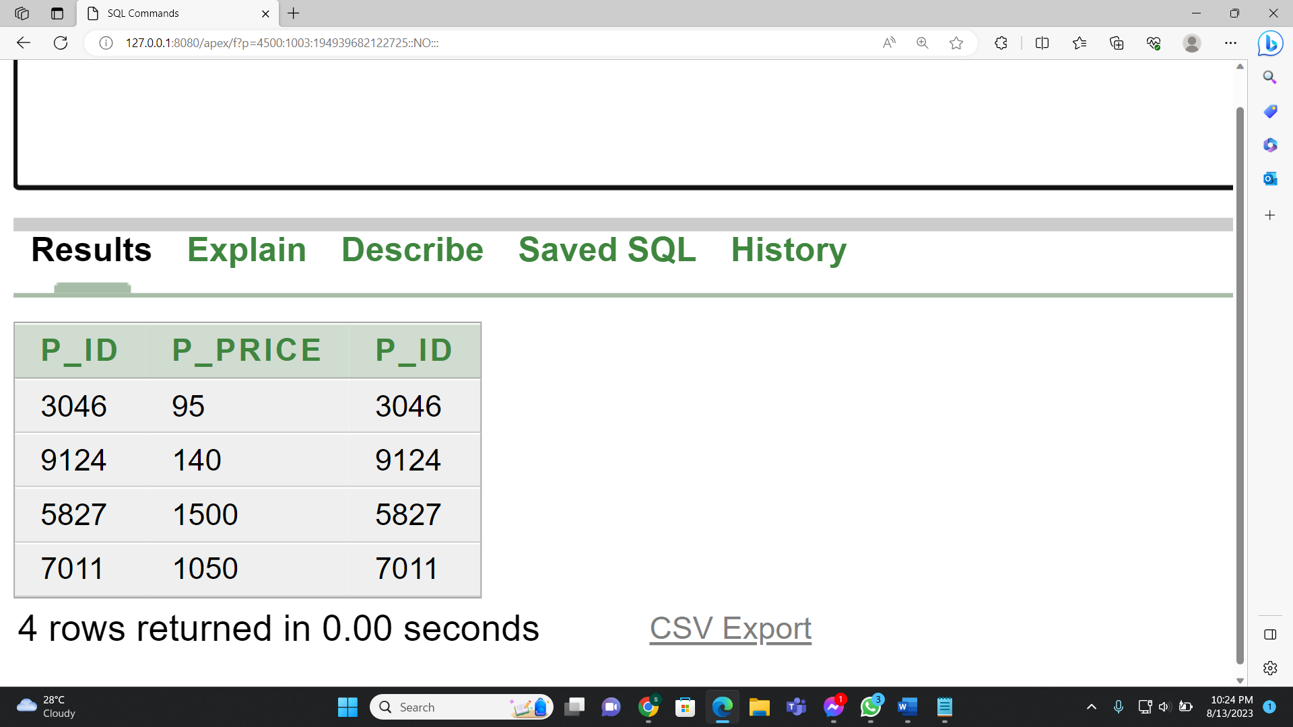

**Outer Join:**

* Write a query customer id, customer name, order id, and corresponding customer id from customer and orders tables including cases, where there might not be a matching customer id in orders table.

**Figure-8.11:**

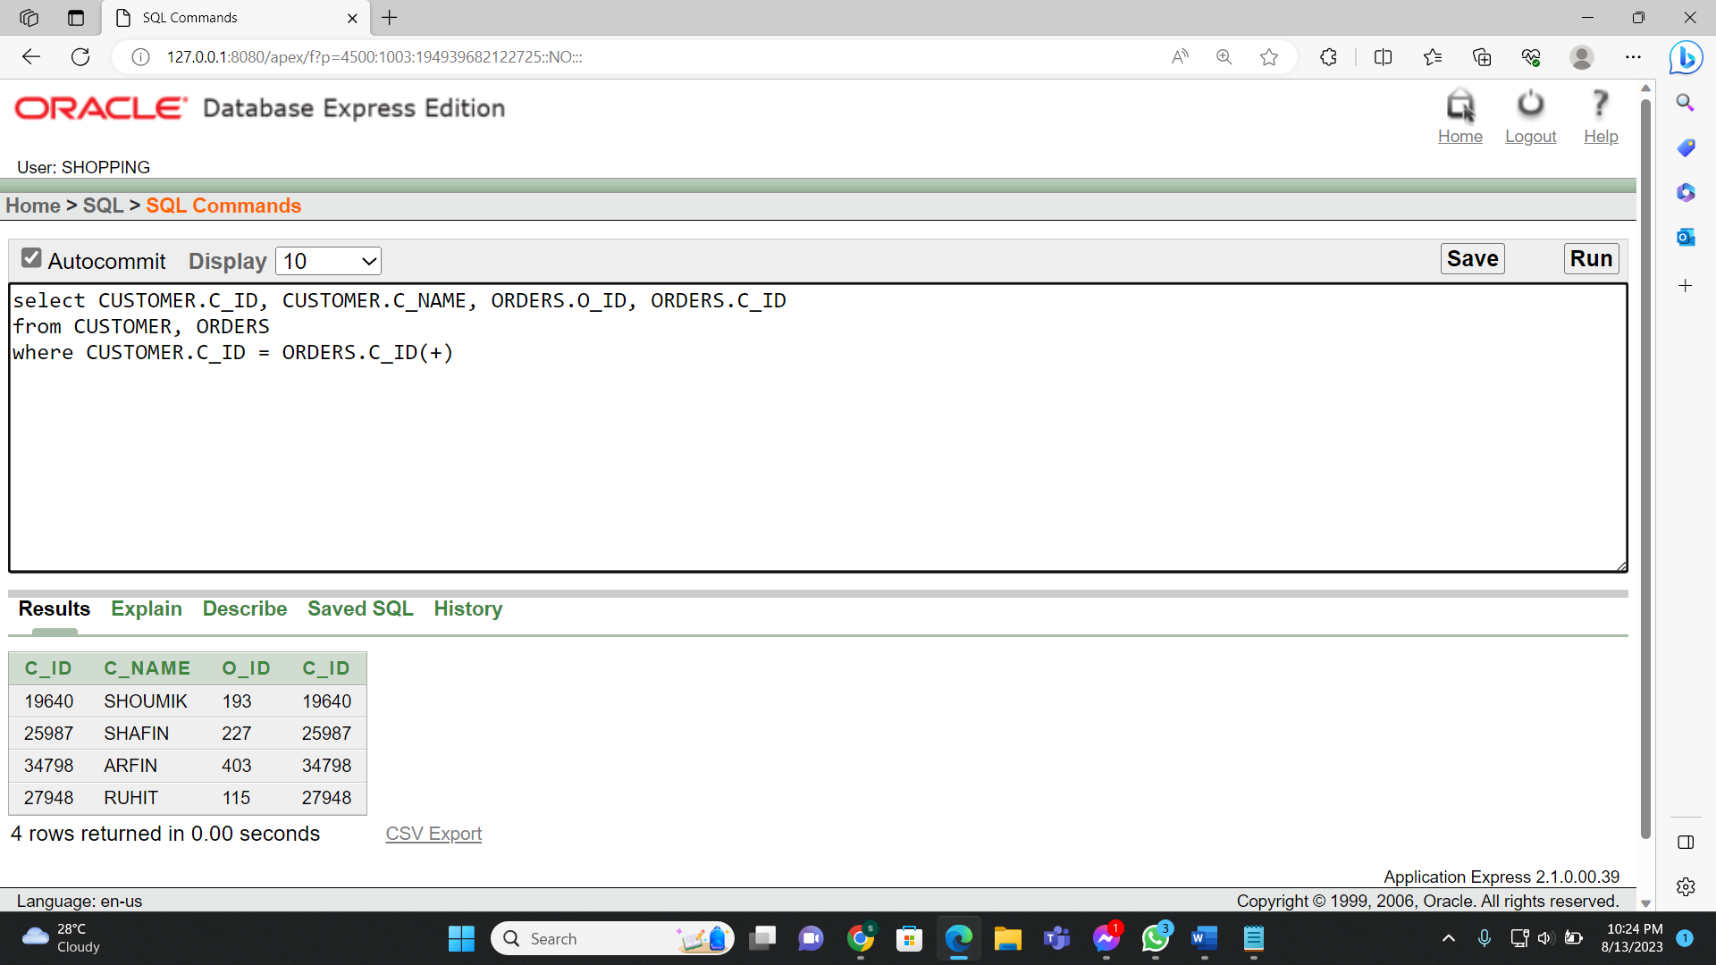

**Figure-8.12:**

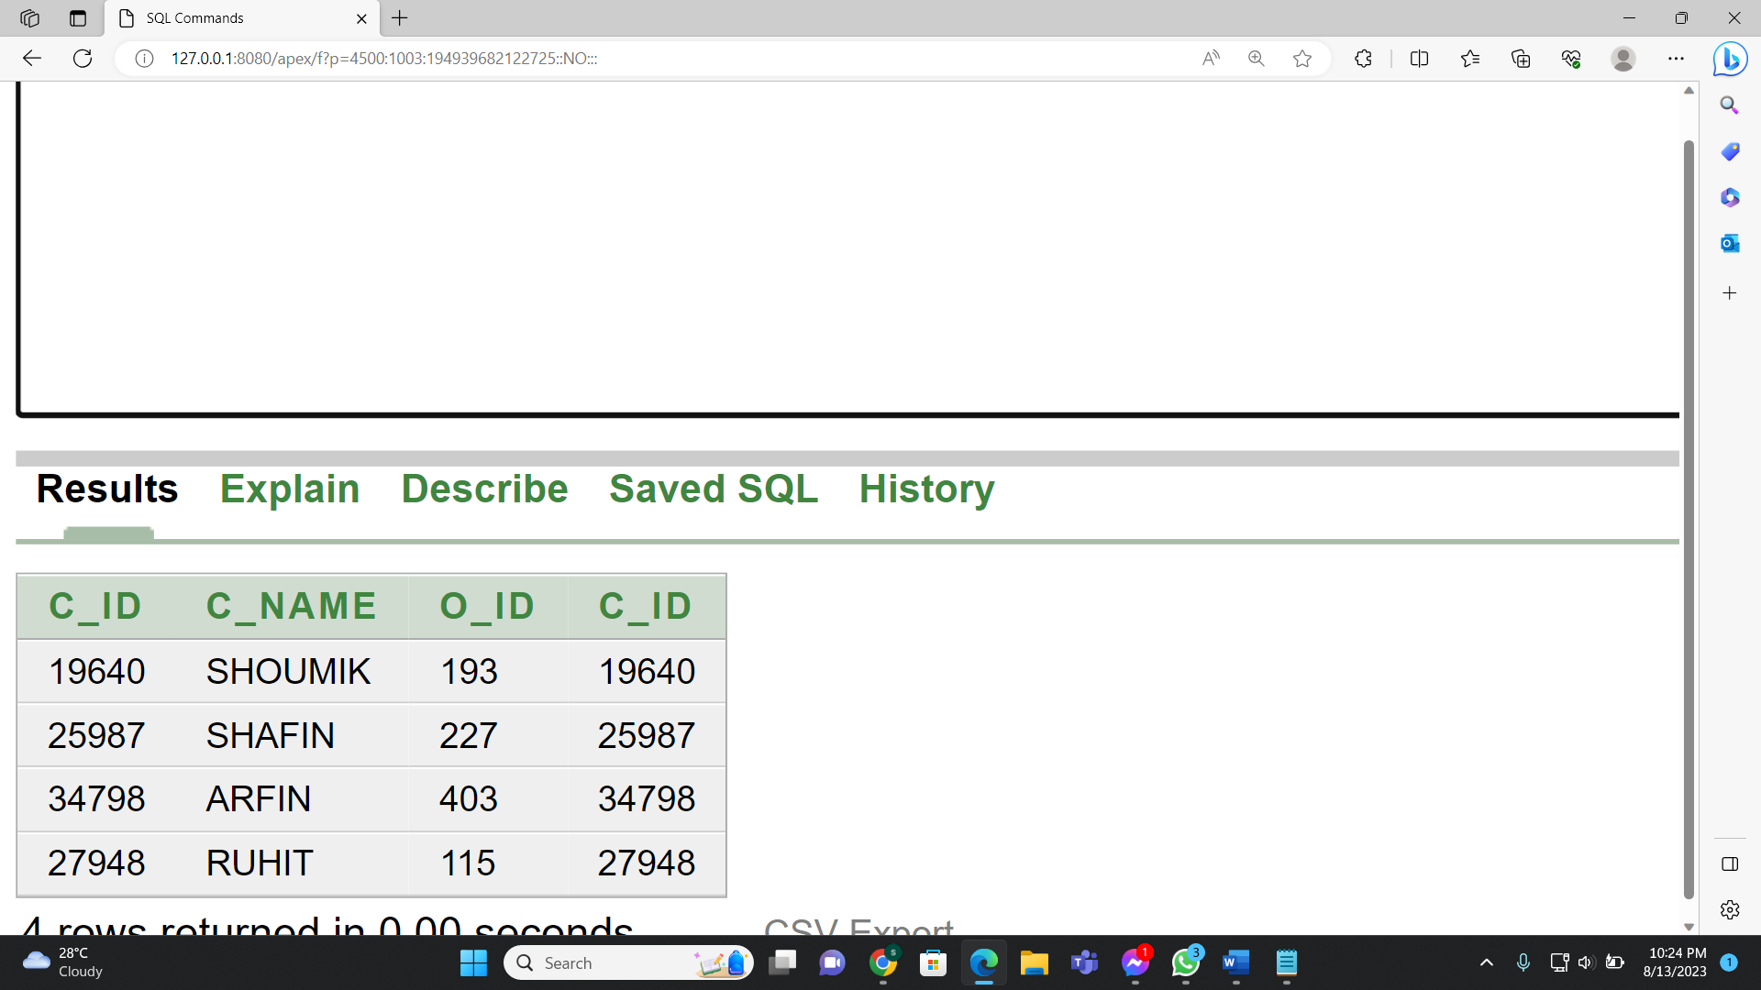

**9.View creation:**

**Simple View**

* Create a view named prices that includes branch ids and product prices from the ‘product’ table where the product table is 7011

**Figure-9.1:**

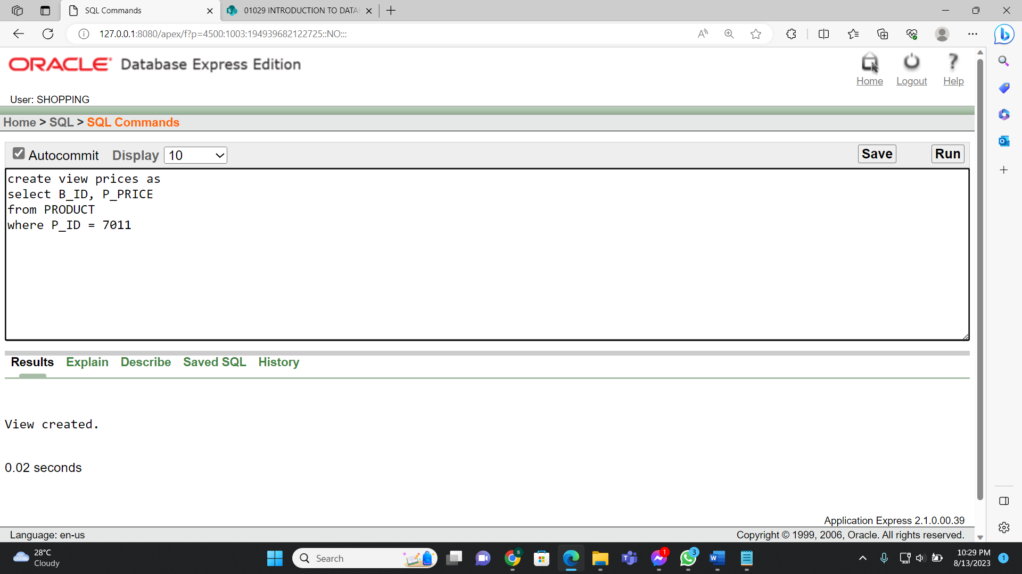

**Figure-9.2:**

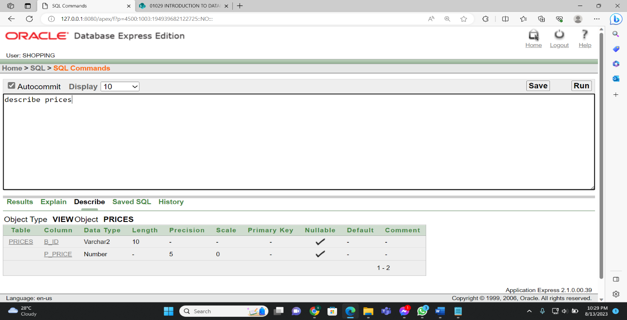

**Figure-9.3:**

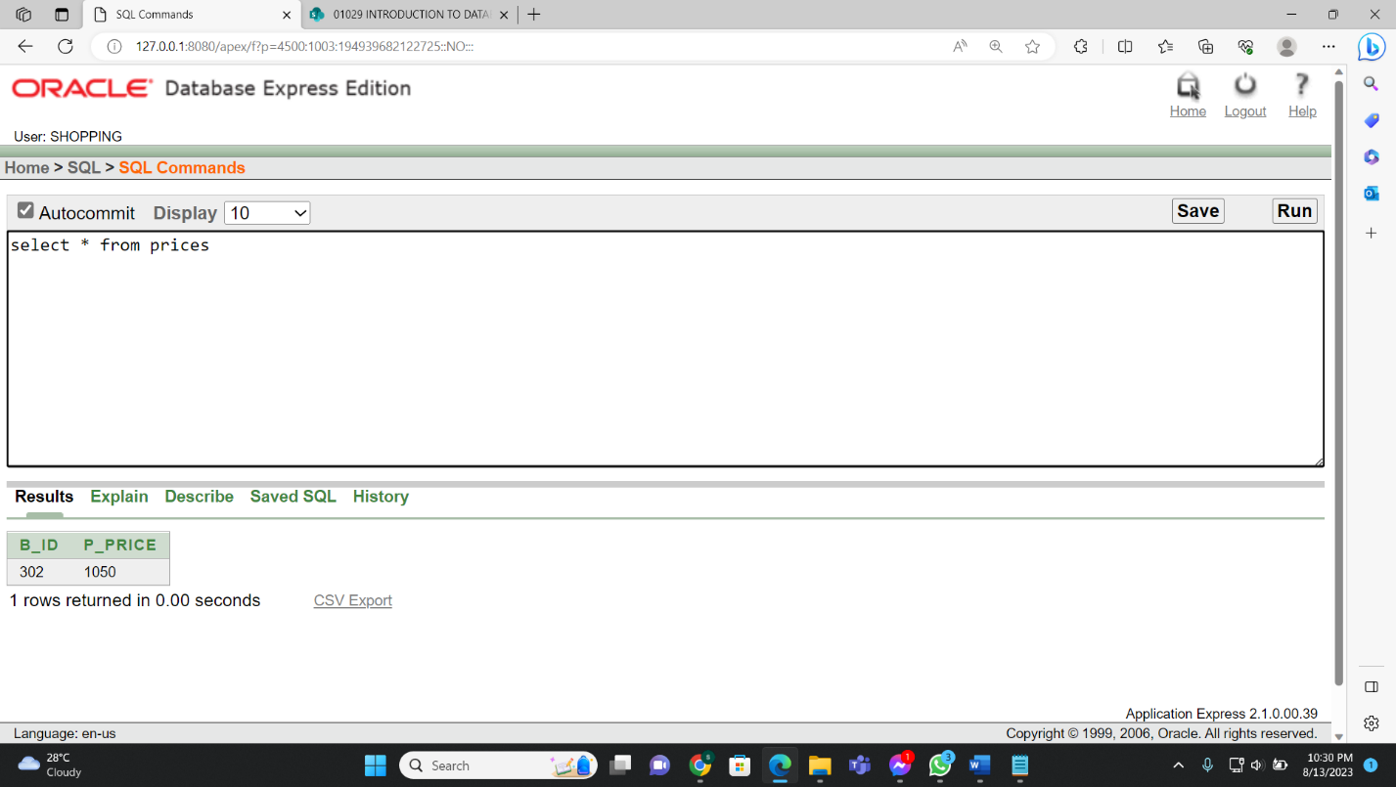

**Complex View:**

* Create a complex view named "Shop” that includes store names, store id, and order ids from the store and order_from_store tables where the store ids match between the two tables.

**Figure-9.4:**

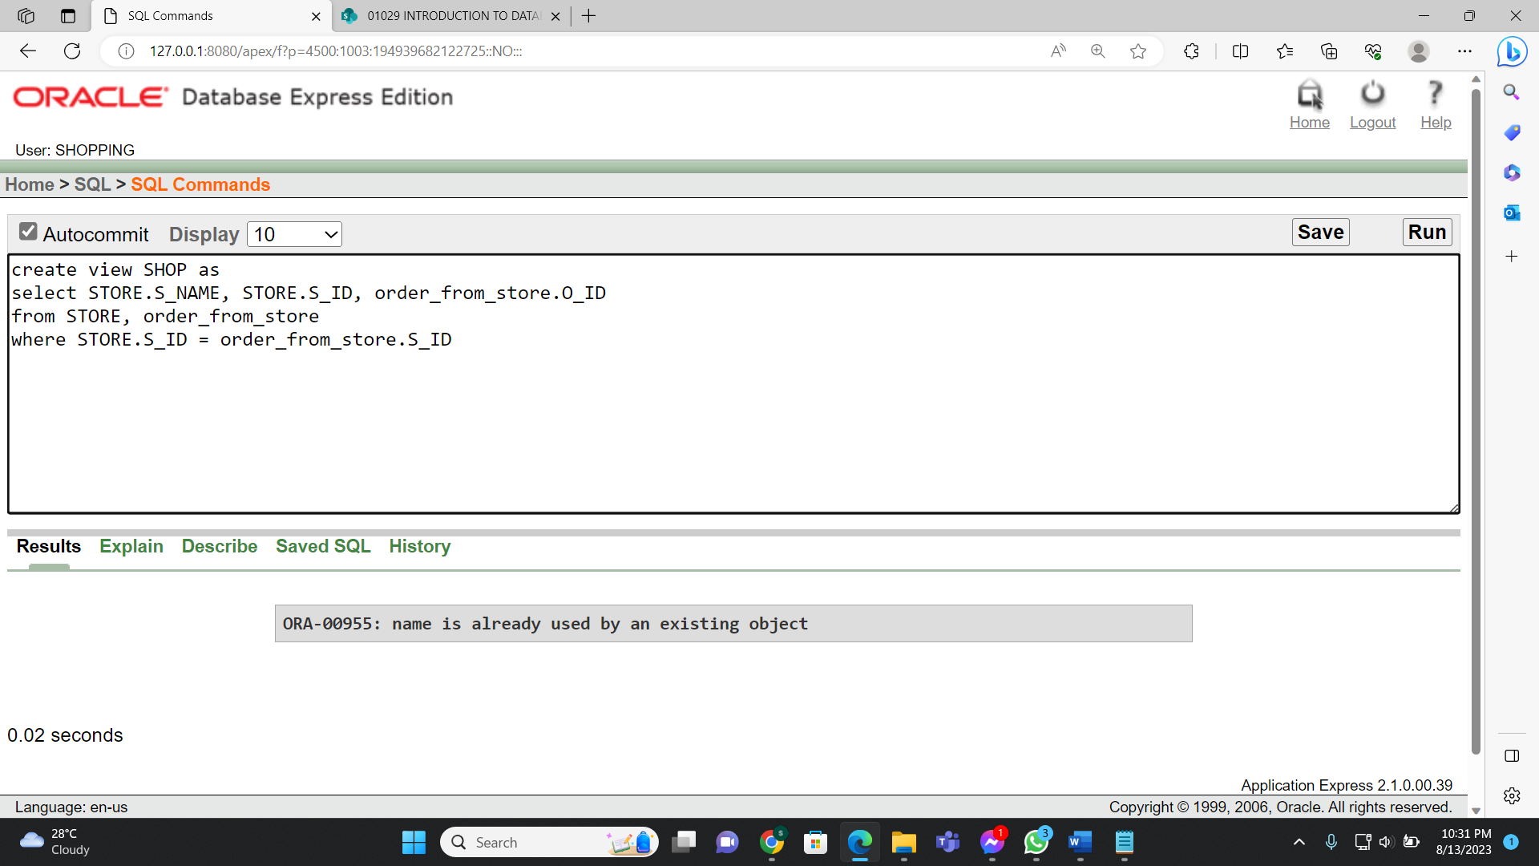

**Figure-9.5:**

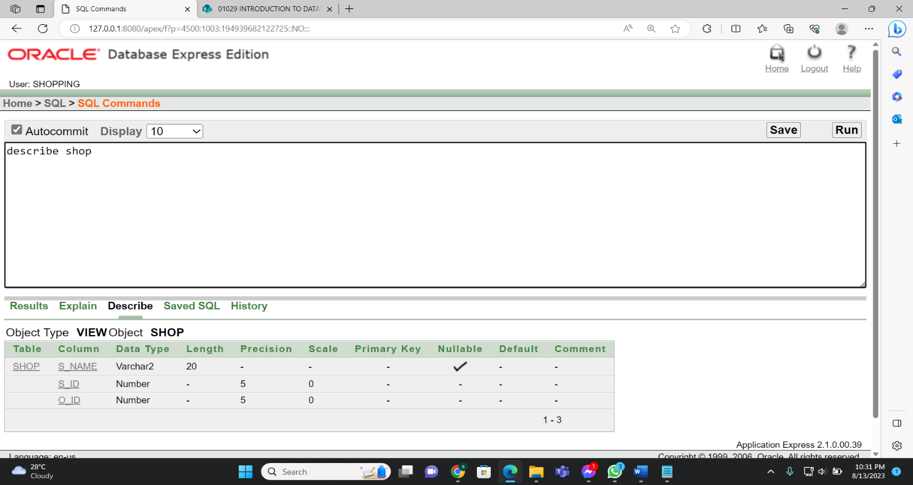

**Figure-9.6:**

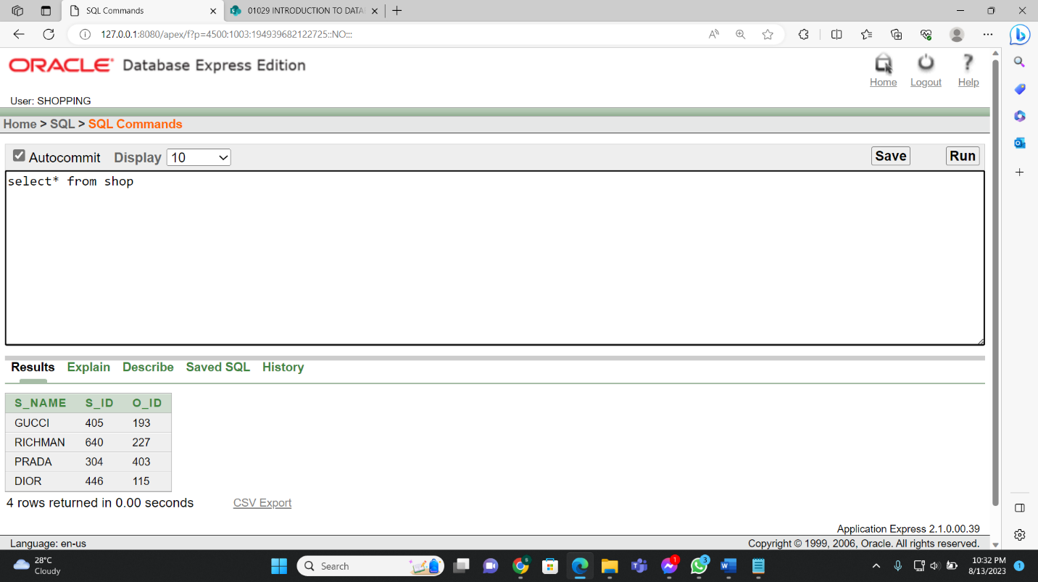

**10. Database Connection:**

For database connection firstly, we need  
1. MySQL java connector (jar file).

2. You need to search (xampp apache mariadb perl php) install xampp server normally.

3. Select the xampp icon control and then start both apache and MySQL. Next go to MySQL admin panel.

4. Now create a Database, inside of it create table and insert the values in the table.

The Pays table in MySQL

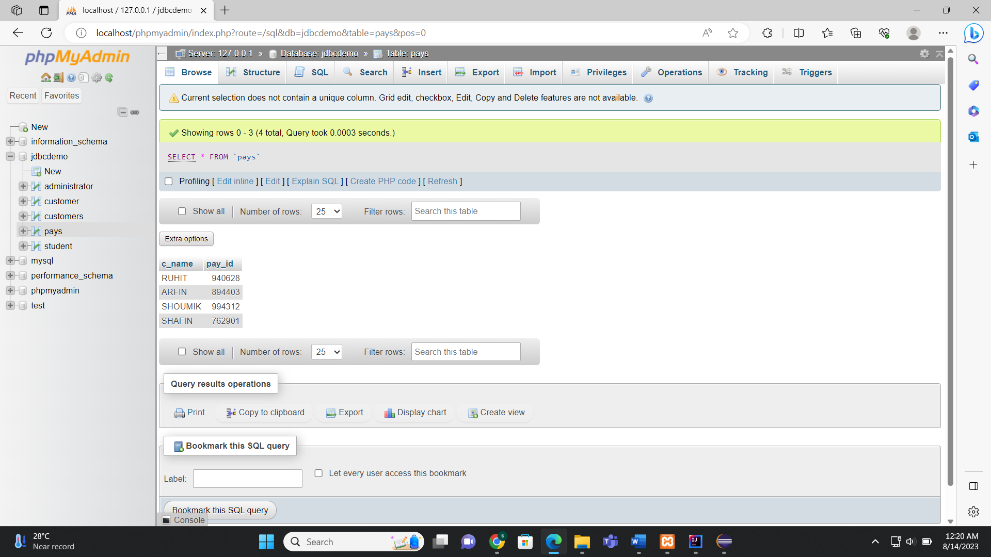

Now we need an IDE. We can use it through eclipse, IntelliJ, visual codes.

Before that, we need these steps for connecting database.

* Register Driver
* Connect the DB
* Create a statement.
* Execute the query () in the resultstmnt.
* Connection close ()

5. Now in the IDE we write the database connection code and add the jar file location in the libraries.

The Pays table’s output will be:

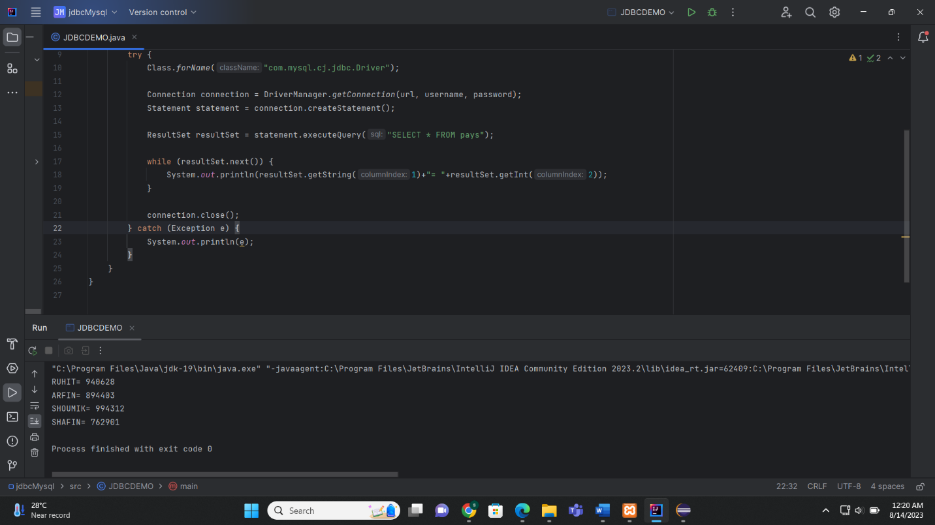

**11.conclusion:**

The process of creating database is a fundamental part that plays a major role in modern information management.This report has highlighted the key steps and considerations involved in this process and emphasizing the importance of thorough planning, design and implementation.

The planning phase involves defining the purpose and scope of the database, identifying user requirements, and selecting an appropriate database management system . A well-thought-out database design is crucial to ensure efficient data storage, retrieval, and manipulation. This includes establishing a clear data model, defining relationships between entities, and optimizing data normalization to minimize redundancy and enhance data integrity